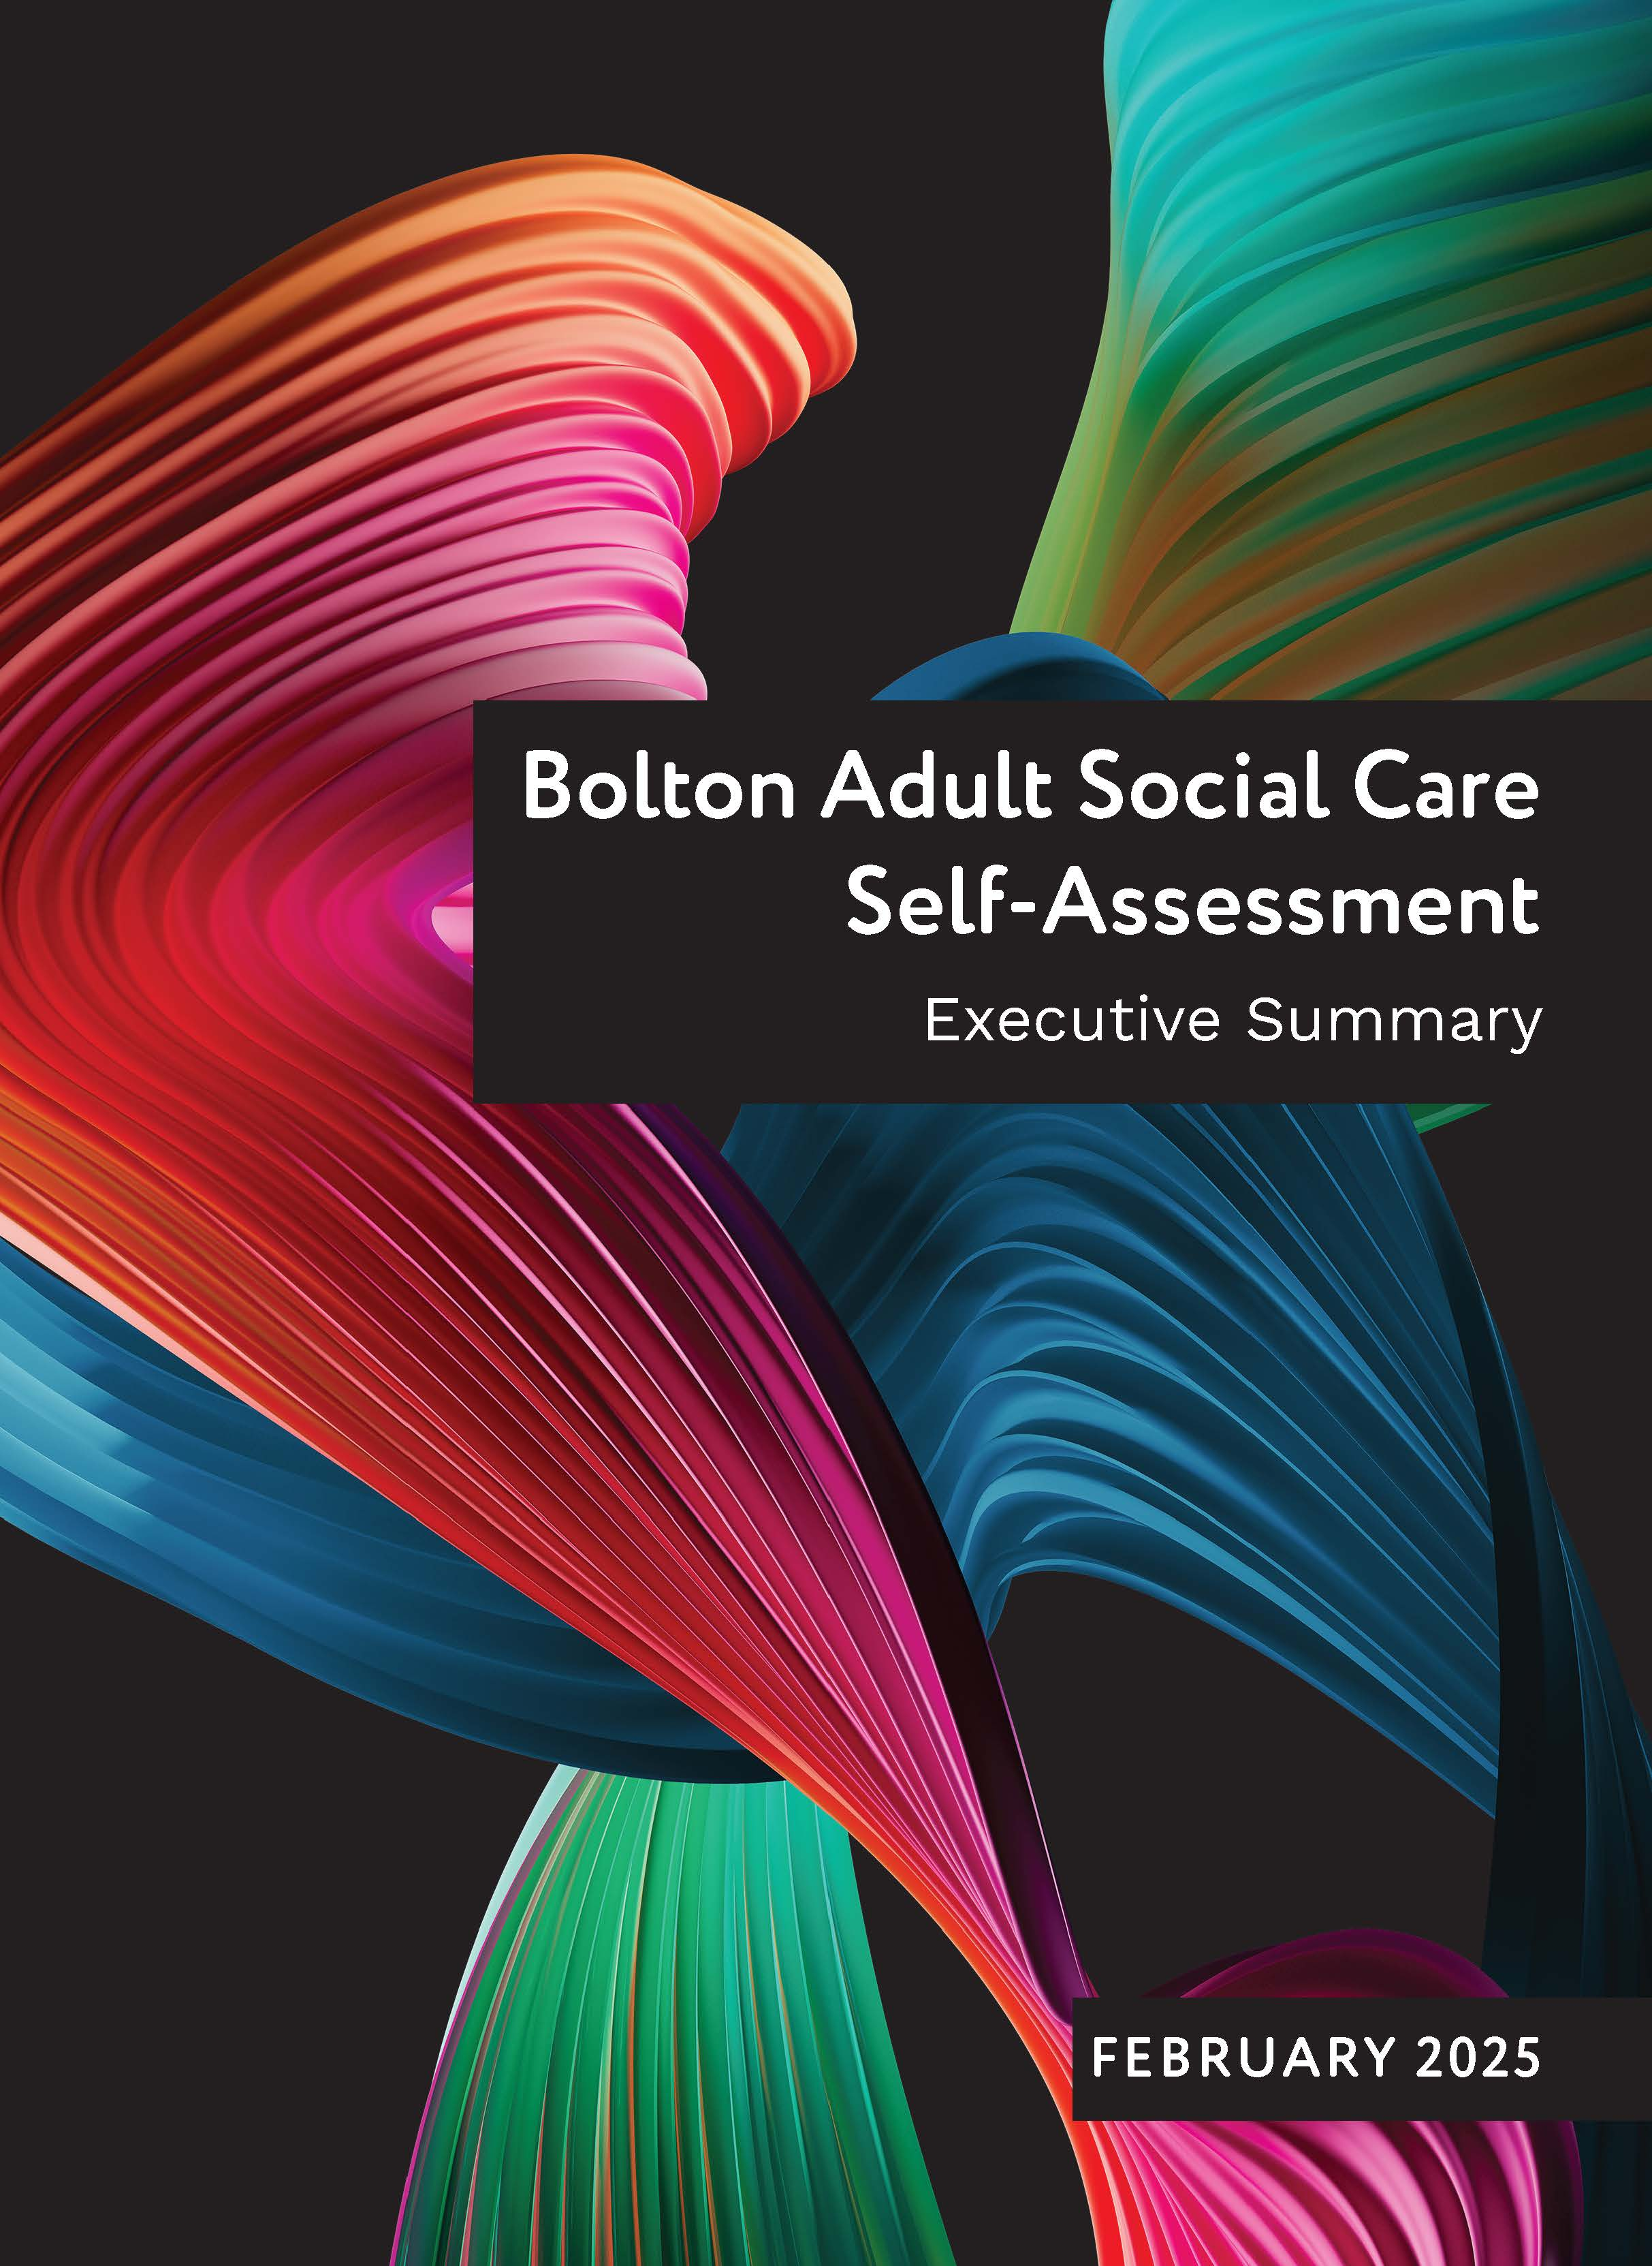

**Foreword**

Making a difference is at the heart of our organisational values and behaviours. For us, statutory duties are a starting point. We engage in sector led improvement to learn, develop and shape our approach to delivering legal requirements in a way that makes a difference for people in Bolton. Our town is unique, with immense diversity and disparity across our population.

Our strong leadership and partnerships enable us to make the best use of resources, and to work together to find joint solutions to our challenges. Adult social care is placed in a wider system that also features prevention and health services. Our shared plans focus on recalibrating the balance of these to really focus on preventing, reducing and delaying the need for more specialist services, in a way that is safe and that secures better outcomes for the people of Bolton.

Working with people and providing support to live well at home is central to our plans. Our adult social care vision is that all Bolton people can live in the place they call home, with the people and things they love, in communities where they look out for one another, whilst doing things that matter to them.

This self-assessment has been developed collaboratively across our leadership and management team, with support from partners. Insights from our workforce and the people of Bolton have helped to shape this position statement and our accompanying Improvement and Innovation Plan, which will help us to build on our strengths and drive forward our improvement programme.

## Our Finances

Bolton Council continues to face significant financial challenges with rising demand and complexity of need, this coupled with rising inflation and fee rates for social care, the Council has had to make difficult decisions on investment in key areas whilst also making cuts year on year.

We have successfully maintained a balanced budget with our strengths based Live well at home approach, With an additional £10m of corporate funds received over the past two years and other inflationary increases, the budget has seen a 22% overall increase. Importantly, Bolton continues to invest in key initiatives with NHS colleagues, such as Dove House and Neighbourhood leads, demonstrating a commitment to growth and collaboration.

**Our Partnerships**

Bolton has a long and strong history of partnership working through our Vision Partnership and with the NHS and wider partners through our Health and Care Partnership (Locality Board). Bolton is one of ten localities within the Greater Manchester Integrated Care Partnership (GM ICP) forming a collaborative network of health planners, providers, local authorities and community members.

Bolton’s Health and Care Partnership has arrived at six local strategic priorities through listening to the voice of Bolton people - these align to the vision for Adult Social Care and wider strategic drivers for Greater Manchester and Bolton as a place. These are overseen through the delivery of our [Locality Plan for 2024-29](https://www.boltonft.nhs.uk/app/uploads/2024/05/Bolton-Locality-plan-2024-2029-spreads.pdf), and the Locality Board governance, which is a joint committee between the Council and Greater Manchester Integrated Care Board (GM ICB).

In addition to the health and care partnership arena, we engage strategically with our partners through a number of boards and partnership groups that are both statutory and non-statutory including Bolton Safeguarding Adults Board, Community Safety Partnership, Domestic Abuse Partnership and Preparing for Adulthood Board. The chairs of these boards meet regularly to ensure strategic alignment of the work and priorities for Bolton.

### Theme One – Working with People

### A group of colorful rectangular boxes Description automatically generatedOur ambition is for Bolton people to live well at home. We will embed strengths-based approaches right across care and support to enable people to have choice and control over their lives. We are committed to ensuring our quality of assessments and case management are of a high standard; to work across our own services and others as needed to enable person centre planning and continually improve through learning, we endeavour to improve embedding feedback from people who draw on care and support.

### Working with People - **Assessing Needs:**

**Strengths**

* We are embedding strengths-based approaches across care and support, enabling people to have choice and control over their lives.
* We have effective collaboration with health, housing, police, children services, VCSE, and providers.
* Co-location and collaboration are our key to delivering multi-disciplinary working. Examples of these are the Integrated Discharge Team, our six neighbourhood teams, Community Learning Disability Services who are all co-located with partners.
* The neighbourhood model has demonstrated positive benefits for people and the workforce with a ‘one team approach’.
* The Early Intervention Team provide proactive support, connecting people to communities. They have a focus on the prevent, reduce and delay ethos and keeping people well for longer.
* There is a dedicated Integrated Discharge Team (IDT) who work seamlessly with health on site at the hospital, and with our step-down short term care services across Intermediate Care Bed-Based Units, Discharge to Assess at Home Service (DTAH) and our Home Support Reablement Service (HSR).
* The IDT has seen an increase in staffing to support the more complex discharges and are supported by a dedicated Housing Officer. They work closely with the Age UK Home from Hospital Service.
* There are efficient assessment processes across all our services, with mechanisms to monitor and prioritise waiting lists. Our median wait times for Care Act assessments and financial assessments are currently below our target wait times.
* We have improved financial assessment process with an online tool, significantly reducing wait times.

**Areas for development**

* The current community directory ‘My Life in Bolton’ needs to be more comprehensive and user-friendly, and the Community Information Directory is being developed for a 2025 launch.
* There is a need to strengthen the approach to risk management by developing operational guidance for staff, particularly for assessment officers at the front door.
* The current partnership arrangement for mental health services is being reviewed, and a mutual decision has been taken to move to an alternative partnership arrangement in 2025. This model will strengthen the social work approach, improve practice and support for the workforce.
* There is ongoing work to improve the timeliness of carer assessments and reviews. A new carers assessment has been developed along with a simpler and fairer system for carer’s personal budgets due to go live in April 2025.
* There is a need to continue the integrated approach to rough sleeping and ensure alignment with safeguarding practices, as well as to improve the matching of people to adapted housing stock and the assessment and adaptation of existing units.

### Working with People - Supporting People to Live Healthier Lives:

**Strengths**

* There is a clear commitment to preventative principles across Bolton partnerships, enabling people to live well at home.
* Our Commissioning, Quality Assurance and Improvement Strategy focuses on prevention across all life stages and to cultivate a robust and varied range of services.
* Public Health continue to lead on promotion of wellbeing, self-care and reducing inequalities.
* Bolton successfully delivered £13.9m of Household Support Funds for targeted support for residents such as pensioners, care leavers and those in receipt of disability related benefits.
* We have redeveloped the adult social care content on the Bolton Council webpages to clearly articulate what adult social care is. Improvements have been made to the accessibility of this information.
* The Prevention and Carers Grants are awarded to VCSE providers and supports a comprehensive range of support for individuals, carers, families, across all ages and our diverse communities.
* Our Early Intervention Team provides one point of contact for all new people seeking professional support. Staff provide tailored information, advice and connection to neighbourhood services.
* As part of the preventative offer, staff attend neighbourhood multi-disciplinary team meetings providing advice, sharing experiences and in some cases proactively take referrals.
* The close alignment of the services in ILS enables coordination of services and access to timely equipment for people.
* Through co-production with people, Bolton developed an offer of additional support to help individuals with the initial set-up and use of direct payments that may include employment of personal assistants.
* Transformation of short term care services is being undertaken across our health and care partnership, which has maximised opportunities within Health and Social Care and successfully supported the reversing of increasing costs. We are proud of the improvements we have achieved to date through our collective work with hospital discharge and intermediate care services.
* We have implemented a Home from Hospital team (D2AH) which has embedded a home first culture.

**Areas for development**

* Ensure the Bolton Prevention and Inequalities Framework is developed and adopted across the system to provide a strategic, consistent, and joined up approach to prevention.
* Successfully launch and implement the Age Friendly Strategy, focusing on health and wellbeing, economic challenges, transport and social isolation.
* Continue to develop and implement the Anti-Poverty Strategy with a strengths-based approach.
* Address digital exclusion by providing digital health and care tools.
* Enhance the accessibility and clarity of adult social care information on the Bolton Council webpages and development of the Community Information Directory.
* Strengthen the links with community services and resources to provide tailored information and advice.
* ILS are working on reducing the number of people waiting as this is a key service to ensure we embed our strengths-based approach and make the best use of resources, ensuring the best outcomes for the people needing our support.
* Continue the redesign of the systems short term care models to better support independence and prevent hospital admissions, learning from tests for change such as Extra Care D2A beds and Dove House.

### Working with People - Equity in Experiences and Outcomes

**Strengths**

* We have signed up to the Skills for Care initiative Social Care Workforce Race Equality Standard. We will use this to address evidence of inequality and make progress towards race equality.
* Bolton Council is also part of the GM People Inclusion Standard that looks at collaborating to drive positive change and equity across Greater Manchester councils, with a focus on a diverse and engaged workforce.
* In Bolton we have staff ‘Allies Networks’, where collectively members of the staff network work collaboratively with leadership teams to bring about positive change.
* The directorate has its own mandatory training matrix offering a varied number of opportunities for staff to gain skills and prevent unintentional discrimination. This includes courses focusing on anti-racism, autism awareness, LGBTQ+ awareness and allyship and neurodiversity.
* Equality Impact Assessment screenings are completed for all proposals taken to DLT and ECM, to identify how proposals may impact positively or negatively on protected characteristics. The EIAs carried out identify that most proposals have had positive impacts.
* We have taken positive steps to our assessment documentation by including mandatory questions to consistently identify individuals who may need additional support or adjustments.
* Through our all-age independent advocacy contract, staff refer to advocacy services for support to people in several areas to ensure those who require support have appropriate representation.
* To support people who may find it more challenging to access employment, we commission an in-house service, BEST. This service supports people who have a diagnosis of Mental Health and/or Learning Disabilities who are unable to access support at a universal level.

**Areas for development**

* Finalise and implement the full action plan for the Social Care Workforce Race Equality Standard.
* Enhance the monitoring and review process for Equality Impact Assessments to ensure continuous improvement and effectiveness.
* Ensure consistent identification and support for individuals needing additional assistance due to disability, impairment, or sensory loss.
* Develop and implement an action plan based on the findings from the analysis of population data to address any areas of disproportionality or unmet needs.

### A diagram of a community Description automatically generated with medium confidenceTheme Two – Providing Support

Our Vision for providing support is that we will make a positive difference every day, supporting our residents to live as full and safe a life as possible and make informed choices with care that is co-ordinated and seamless for the person. To that end we strive to commission and offer a wide range of services that support independence and that meet the needs of our diverse communities in Bolton.

### Providing support - Care Provision, Integration and Continuity:

**Strengths**

* We have a newly established Council Commissioning Board which will have oversight on the delivery against our Commissioning and Quality Assurance and Improvement Strategy.
* Our Market Position Statements help identify future demand for care and services across the borough and utilise data and information on our population need. The MPS provide vital information to local providers to inform business plans and develop new services.
* Bolton has strong understanding of the gaps and priorities in its Age Well services and is actively addressing them through a range of strategic initiatives, including tackling market challenges for dementia nursing bed supply, working to expand short term care and respite options and the opening of a new Extra Care scheme.
* Bolton has a strong market for homecare and community providers on a framework basis. There are very low wait times for acquiring homecare packages.
* Our new Home Care Contract 2024-2028 has been developed in consultation with people, providers and key stakeholders. The contract introduces structured referral processes, response times and improved quality assurance mechanisms.
* We have recently held multi-disciplinary workshops to analyse the findings from the statutory Adult Social Care and Carers Surveys.
* Bolton has a robust and well-established approach to Quality Assurance underpinned by a Quality Assurance Framework that is applied to our commissioned and in house provider services. This encompasses support to providers, contract and quality visits by the Quality Assurance & Improvement Team.
* We have a robust provider support offer to implementing the provider failure protocol. Where providers have areas of development, the Quality Assurance and Improvement Team support in a bespoke way.

**Areas for development**

* Improve collaboration with stakeholders, including residents, families and partners to co-produce strategic priorities.
* Launch of a new Technology Enable Care strategy towards the end of 2025, to further promote independence and improve care delivery.
* Further develop brokerage functionality and market intelligence to ensure a sustainable and resilient care market.
* Specialist housing remains a focus, with efforts to improve internal structures to reduce the time it takes to bring forward land/assets to support developments.
* Continue to enhance quality assurance mechanisms and support for providers to maintain high standards of care.
* Focus on long-term investment in care provision to support sustainable service delivery and market stability.

### Providing support - Partnership and Communities:

**Strengths**

* Having a place-based partnership enables us to collaborate to address specific Bolton based challenges. All of the Bolton partnerships have neighbourhoods at their core.
* There are very strong working relationships and joint approaches to collaborative commissioning with the ICB. A Commissioning workshop in September 2024 focussed on co-producing a set of Integrated Commissioning Principles.
* Bolton developed an Integrated Partnership All Age Carers Strategy which was co-produced. We host a monthly Bolton Carers Integrated Partnership Group that is co-chaired with a carer who is also the Chair of Bolton Carers Support.
* Bolton has a thriving Voluntary and Community Sector (VCSE) that brings in a huge amount of social value and expertise to the system and is well placed to reach and support our communities. The Council’s Wider Leadership team meet quarterly with all VCSE group leads to consider ways to work in partnership for our communities.
* Commissioning also holds monthly meetings with VCSE leads and Health to co-produce services that meet people’s needs.
* To offer greater stability to VCSE organisations, we have developed an All-Age Prevention Flexible Purchasing System in collaboration with the sector. We have aligned support to ensure that smaller VCSE organisations are ‘commissioning ready’ and can benefit fully.
* There is a specific innovation fund ‘Bolton Fund’ which supports innovative community projects. The fund is evolving and there is a focus on supporting smaller grassroot groups.

**Areas for development**

* To grow the membership of the Bolton Carers Integrated Partnership Group to further reflect our diverse communities in Bolton.
* To launch the refreshed carers assessment and reset the value of the carer’s payment which is due to be launched in April 2025.
* Promote the sharing of learning and good practices across working groups, networks and workshops.
* Continue to shape the market to address areas of gaps and challenges such as respite services, expediting supported living schemes and the 10yr Housing with care needs prospectus.

### Theme 3 – Ensuring Safety

### Our aspiration is that the care and support we deliver is planned and co-ordinated in a way that helps people feel safe when coming into or moving between our services and enables them to only tell their story once.

### Ensuring Safety - Safe Systems, Pathways and Transitions

**Strengths**

* Bolton has low numbers of people awaiting assessment, which are monitored via live dashboards that give clear oversight to managers. This helps in managing waiting lists effectively and ensuring timely support.
* Our Social Work and Occupational Therapy teams have a daily duty function which triages contacts and manages priority and risk to support people to ‘wait well’, escalating to managers when required.
* There are efficient assessment processes, with mechanisms to monitor and prioritise waiting lists. Our median wait times for care assessments, are currently below our target wait times.
* Within Liquid Logic, we have developed a specific DoLS Episode, showing where in the process the person is. This consolidation of relevant documents and case records into a specific DoLS area facilitates effective management.
* We are strong in ensuring a smooth and supportive move from Children to Adult services with a dedicated Transition team. We respect the views, wishes and needs of young people and are inclusive of families in the planning process.
* Staff understand and know the future ambitions of the young people, in advance of moving into Adult Social Care by attending EHCP from 14 years onwards. This ensures that through assessment and support planning, the young person’s needs are well understood and planned for through the transition process.
* Multi-disciplinary teams work together to ensure young people’s needs are understood and planned for, minimising the need for families to repeat their stories.

**Areas for development**

* While overall performance relating to waiting lists is good, there are specific areas with longer waits that are monitored and interventions taken, including a commitment to use agency where needed.
* Continue to improve the transition process from Children to Adult services, ensuring it is smooth and supportive.
* To enhance our risk management strategy by developing operational guidance for staff, set to be completed by Summer 2025.
* Ensure the new risk management guidance is well-integrated into the strengths based programme to support officers in triaging and identifying risks.

### Ensuring Safety – **Safeguarding**

**Strengths**

* The Bolton Safeguarding Adults Board (BSAB) has strong engagement from partners and provides the oversight and scrutiny of all our safeguarding adults work and partnership arrangements. The Board is led by an experienced independent Chair who is the scrutineer for Bolton’s Children’s Safeguarding Partnership.
* Overall partnership engagement with the BSAB is strong, with an increasing culture of working together to achieve better outcomes.
* A diagram of a key area

  Description automatically generated with medium confidenceThe Board has a clear vision and strategic plan and continues to deliver key improvements.
* There is a strengthened approach to organisational data and assurance, through a revised and strengthened Safeguarding Effectiveness sub group, with multi-agency dashboards to inform decision making.
* We have a well-established multi-agency Safeguarding Intelligence Forum which is proactive in monitoring and supporting care providers where there are quality or sustainability concerns.
* The development of the Safeguarding Adult Review (SAR) subgroup has led to increased referrals and reviews with learning taking place with partners. This is routinely reported into the Safeguarding Board and has contributed to the national safeguarding SAR review.
* Bolton has a multi-agency safeguarding hub which is co-located with Children’s services, Police and Housing. This has been effective in responding in a timely manner to concerns. We have strong representation on forums to ensure people with care and support needs are considered in broader safety planning.
* Work has been completed through the BSAB subgroup to develop a greater understanding across agencies of Safeguarding and introduced an online professionals’ portal for making a referral that has resulted in improved quality.
* We have fully adopted Making Safeguarding Personal in Bolton and report positive outcomes for reducing risk and meeting people's outcomes to resolve their circumstances.
* There has been targeted campaigns and efforts to raise awareness of domestic abuse in older adults, this has led to a greater awareness which has been evidenced through increased levels of referrals for support.

**Areas for development**

* Training in relation to Mental Capacity Executive Functioning needs to be undertaken. This work will be overseen as part of the Quality of Practice subgroup.
* Development and implementation of the Bolton Adults Risk Management (BARM) Policy and Practice Guidance which will offer a risk management framework to enhance multi-agency collaboration for adults who are at significant risk and present challenges.
* To finalise the comprehensive review of our current safeguarding documentation which is due to be rolled out in 2025 and will include an updated practitioners guide.

### Theme 4 - Leadership

### Our ambition is to have a cohesive Vision and Strategic Plan for the Directorate that demonstrates a clear golden thread to deliver better outcomes for Bolton people, where we invest in and value our workforce, who are supported by effective leaders and good governance.

### Leadership - **Governance, Management and Sustainability**

**Strengths**

* Our Adult, Communities and Integration Directorate has clear governance structure with established roles, responsibilities and accountability systems to ensure quality and sustainable care.
* There are efficient and transparent decision-making processes through a structured Cabinet and Executive Cabinet Member.
* We have positive working relationships with our Trade Unions through regular Joint Operational Groups (JOGs) and Directorate Joint Consultation Committee (DJCC) meetings.
* The council has recently refreshed its approach to risk management and audit. The Quality, Performance and Finance Board oversee risk management planning across the Directorate.
* Our senior leadership team is stable and well experienced and has strong internal and external collaboration.
* We have effective leadership meetings, with regular Directorate Leadership Team (DLT) and system leadership meetings to drive operational change and oversight.
* Our Quality, Performance and Finance (QPF) Board, provides oversight, assurance and management of key risk and drives forward transformation and innovation.
* There are monthly monitoring of financial positions and savings, with detailed scrutiny. There is a positive recognition council wide in supporting the demands and budget allocations for adult services.

**Areas for development**

* The Head of Service Leadership Team has been very stable for many years but is currently experiencing a level of natural turnover including the PSW position. Additional capacity has been sourced to bring support and stability to services whilst recruitment and consideration of longer term capacity are evaluated.

### Leadership – **Learning, Improvement and Innovation**

**Strengths**

* The service has a dedicated transformation and improvement team and support a range of projects including; supporting the establishment of Dove House, strengths-based practice review, neighbourhoods establishment, demand strategy.
* We continue to innovate our services through digitalisation, with the successful implementation of an online financial assessment.
* There is active participation in sector led improvement and learning from others.
* We have commissioned external support from ‘Facilitate’ to assess our present adult social care pathway model. This review has informed a step change improvement programme to move us to a new practice model and a robust strengths-based culture over 2025-26.
* Learning from quality of practice case audits and moderation is being embedded to help us understand our practice strengths and target individual and collective areas for improvement. Quarterly performance reports including a dashboard come through to the QPF Board for assurance.
* The Principal Social Work Team provide and support a positive learning culture, and a professional development framework for Social Workers, Social Work students and unqualified staff working in the statutory services. The Principal Social Work Team has a dedicated area on the Bolton Council Intranet site, which can be accessed by all council staff.

* Our Social Work Apprenticeship scheme supports recruitment and retention and an opportunity to ‘grow your own’ ethos.
* The ASYE program supports new social workers with workshops and personalised plans.
* Staff engagement sessions take place on a quarterly basis and are predominantly in person events with staff from across all services in the Directorate.

**Areas for development**

* Continue to develop our approach to co-production and engagement. The Adult Social Care Co-Production Approach will be informed by the Council wide approach to engagement and co-production that is due to be launched in June 2025.
* Continue efforts to support digitally excluded groups with access to digital tools and skills.
* Harness the use of Artificial Intelligence (AI) as we modernise support services to deliver work more effectively. A pilot area has been tested and is currently being evaluated.
* Implementation of the strengths-based programme, which will also align with the update of all adult social care advice and guidance, policies and strategies.
* Consider and implement audit findings including recording carers’ needs and case recording, and how strengths-based practice is considered with people and carers.
* Finalise and implement the Adults Social Care Workforce Strategy and monitor progress against the action plan.