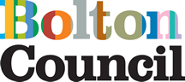

**Extranet Guidance**

**for Schools – Searching for Items**

|  |  |  |  |
| --- | --- | --- | --- |
| **Version** | **Created Date** | **Amendment made** | **Amended by** |
| 1.1 | 05.11.2024 |  | MT |
|  |  |  |  |
|  |  |  |  |

**Searching for your communication (news article) or resource (documents)**

Log in [SLA Online (sla-online.co.uk)](https://secure2.sla-online.co.uk/default.aspx?logo=105)

Enter your school email address (this is your username) and your password.

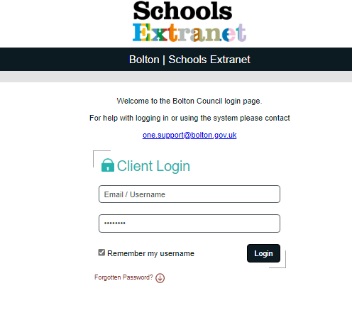

Once you have logged in you will be taken to your personalised home page, showing your name and the name of your school.

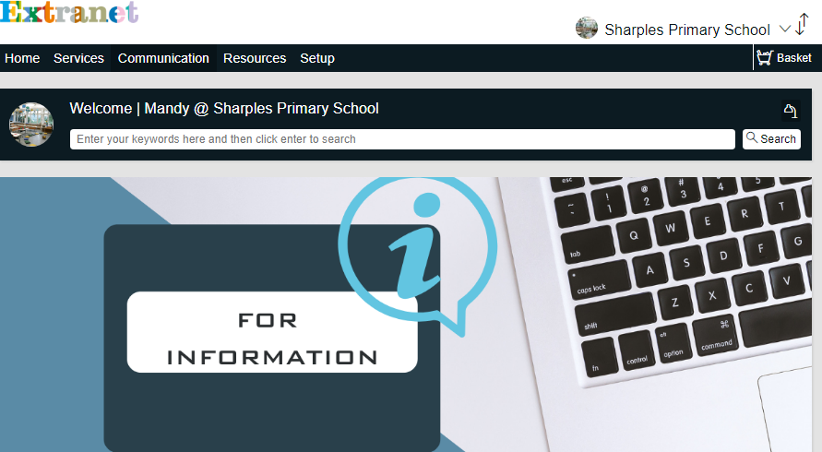

1. **Home – Global Search**

The Home tab is a ‘global search’ field and is used to search for all services, active news articles or documents using the title of the document or a keyword.

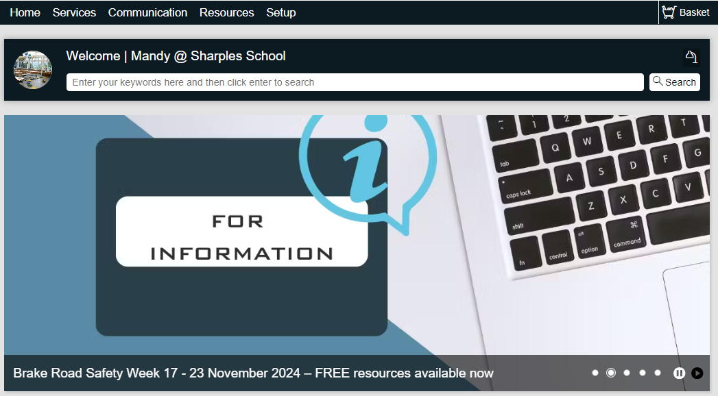

Type your keyword in the search bar i.e. census

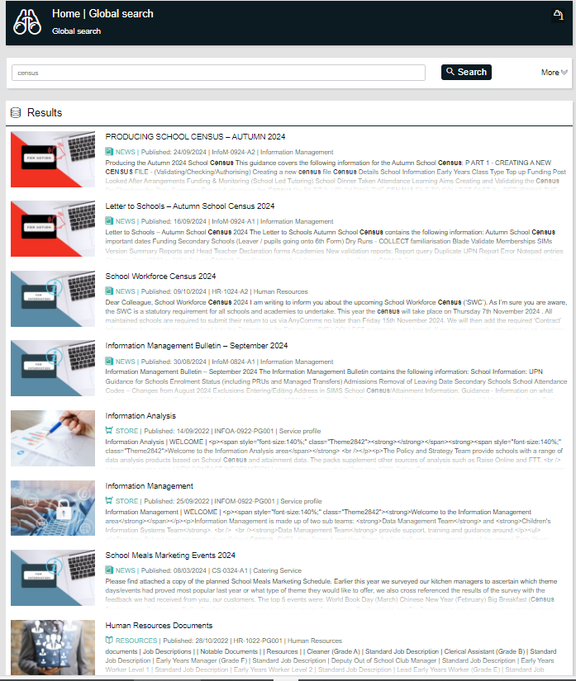

The global search has returned any service, any active communications (News) and any resources (Documents) that includes the word census.

By selecting the ‘More’ option you can filter your search to bring back just News or Resources. We do not currently use blogs, training, or store.

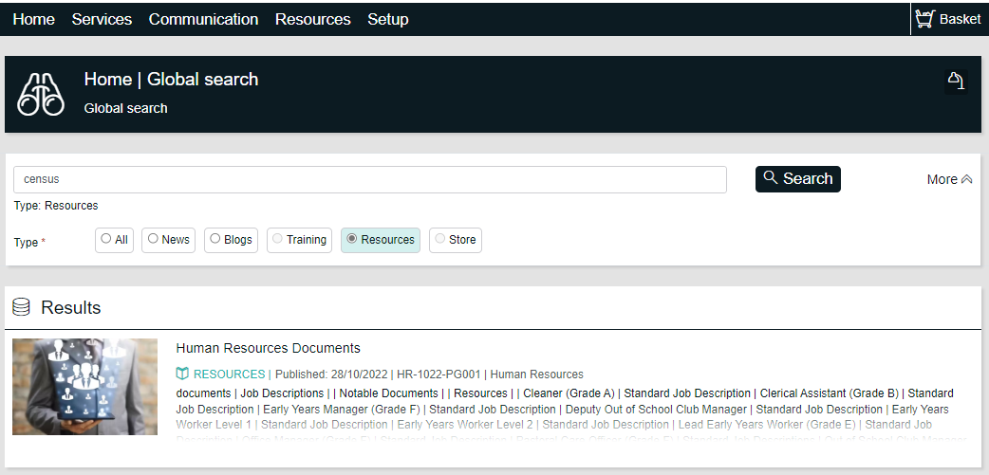

1. **Quick Links**

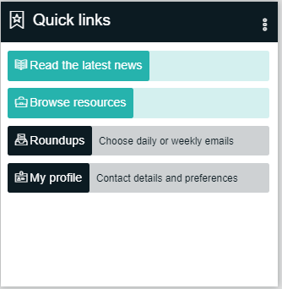

You can use this tile to read the latest news (Communications) or

browse resources – this is the list of all the providers.

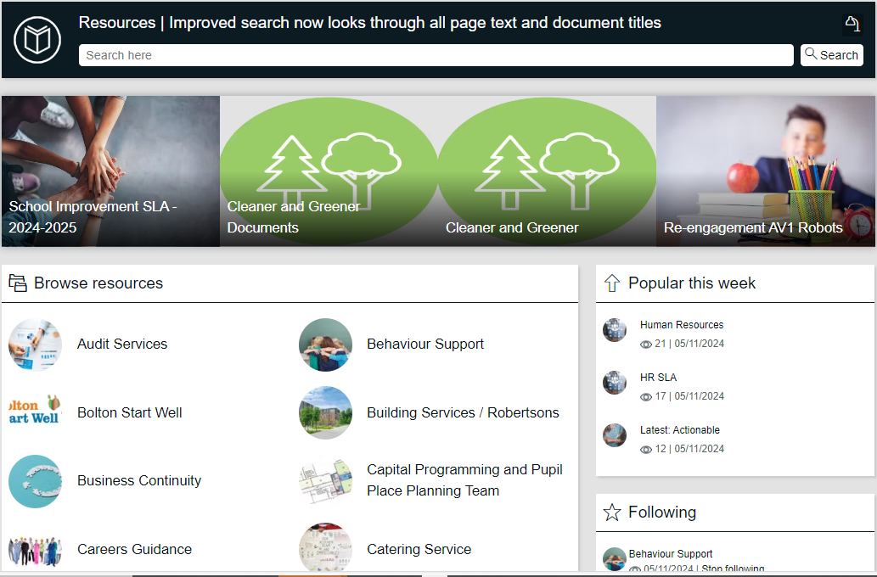

When you select the provider i.e. Behaviour Support, this takes you to the Service Hub page – where you can view the latest Articles for Action and Articles for Information, About us and key contacts and Documents and SLA Documents.

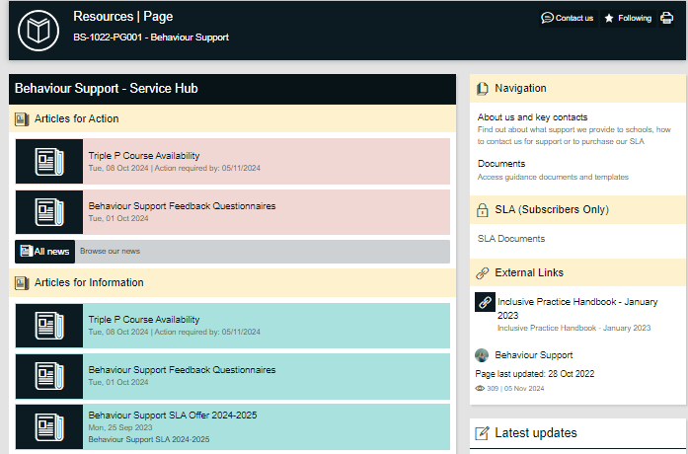

Under the Navigation tile click either:

**About us and**

**key contacts** - to see the useful numbers and details about what the service provides.

**Documents** - to view the uploaded resources.

**SLA Documents**  - If the service offers an SLA and you subscribe to this you will see any

resources that have been uploaded just for service who buy back the

SLA. Not all services will have SLA documents to post.

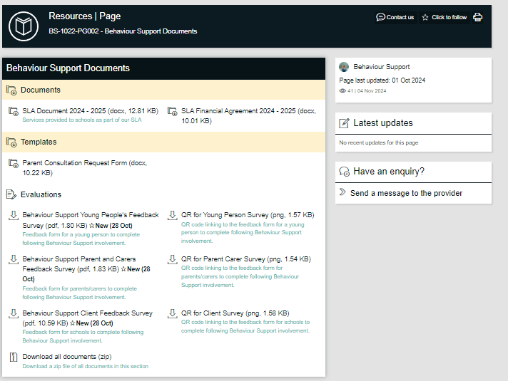 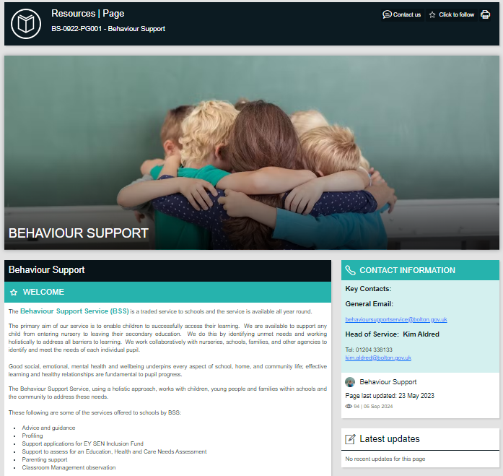

1. **Latest News**

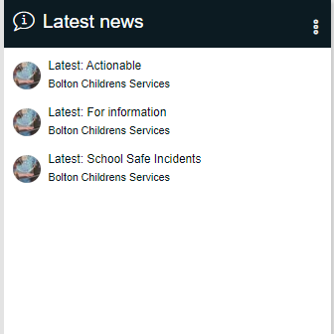

By selecting Latest Actionable, For information or School Safe you will see the latest 10 items in date order.

1. **Communication and Resources Search**

**Communication**

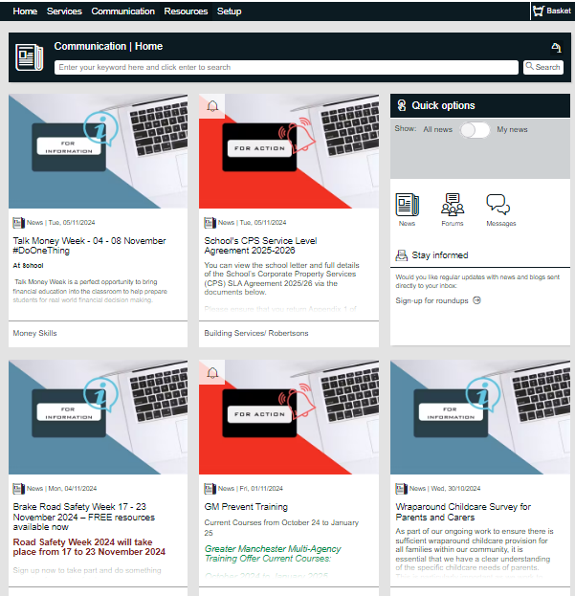

Type in your keyword into the search bar. This will return active news articles that contain your keyword.

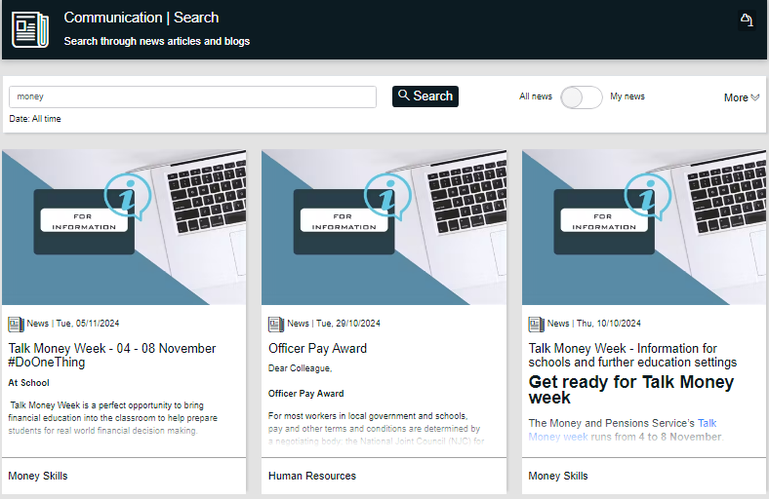

You can select More to filter further i.e. articles for action, last 7 days, provider.

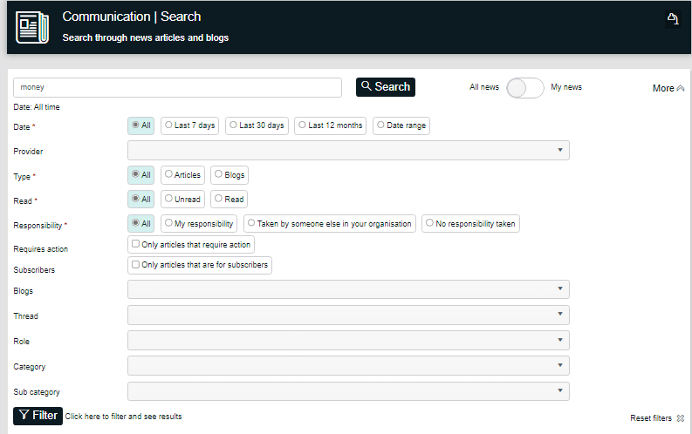

**Resources**

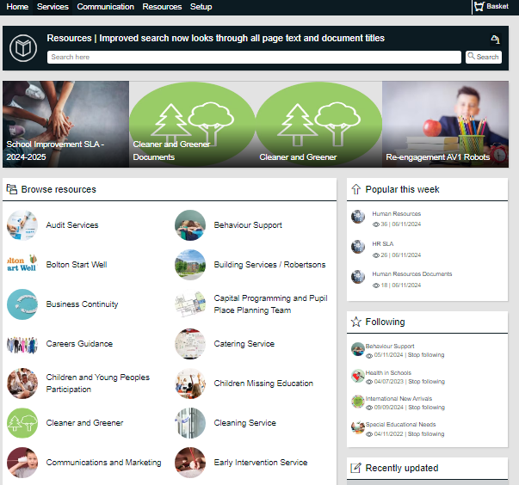

Select the provider from the list, you will then be directed to their Service Hub Page, where you will find latest news articles for action, for information, about us and useful contacts, documents, and SLA documents.