
APPLICATION FORM FOR A LICENCE TO DRIVE A PRIVATE HIRE VEHICLE
Local Government (Miscellaneous Provision) Act 1976

GUIDANCE NOTES FOR THE ASSISTANCE OF PRIVATE HIRE DRIVER APPLICANTS
If NEW APPLICANTS: If this is your first time applying for a licence to drive a private hire vehicle, guidance is available
in ‘A GUIDE TO BECOMING A HACKNEY CARRIAGE OR PRIVATE HIRE DRIVER’, a copy is available to view on
the Council Website on the ‘download tab’ at https://www.bolton.gov.uk/downloads/download/123/private_hire_driver_licence

New applicants are required to complete all the steps listed a) to g) below and provide evidence that the
following assessments have been passed - The Screening and Knowledge Test provided by Bolton College & The Practical Driving Assessment Test.

The GUIDANCE NOTES below explain which steps you need to complete to apply for a licence to drive a private hire vehicle.

All applicants must complete the steps listed a) to d) below. The steps e) to g) will need completing if the GUIDANCE NOTES say they are required:

a) Application form (see note 1 below)
b) Licence fee (see note 2 below)
c) Driving Licence and DVLA ‘Check Code’ (see note 3 below)
d) One colour passport size photograph (see note 4 below)
e) Medical fitness ‘Statement of Fitness’ and ‘Certificates of Medical Fitness’ (see note 5 below)
f) Disclosure & Barring Service ‘Enhanced Disclosure Certificate’ (DBS/CRB) (see note 6 below)
g) Passport, Visa and right to work and right to remain in the UK (see note 7 below).

To arrange an appointment to submit your application contact the Licensing Team by calling 01204 336584 (option 1) or email the team at licensing.unit@bolton.gov.uk

GUIDANCE NOTES:

1. Application Form
1.1 All pages of the application form must be completed in full leaving no questions unanswered, use black ink and capital letters, unless directed otherwise.
1.2 It is your responsibility to complete the form in full.
1.3 Incomplete forms will be rejected.
1.3 Some personal data is duplicated on the pages of the application form. This is because each page is scanned and stored separately on your electronic record.
1.4 The form is available to download from the Council’s Website, on the ‘download tab’ at https://www.bolton.gov.uk/downloads/download/123/private_hire_driver_licence

2. Fee

  - The current licence fees are available to download from the Council’s Website, on the ‘download tab’ at https://www.bolton.gov.uk/downloads/download/123/private_hire_driver_licence
  - We no longer accept payment by cash or cheque.
  - All payments must be made by either Debit or Credit Card

3. Driving Licence and ‘Check Code’ Number

3.1 You must produce a valid UK Driving Licence with this application form.
3.2 You must insert, at number 16 on the application form, the DVLA ‘Check Code’ number. This number is available from the DVLA ‘View or Share Your Driving Licence Information’ and can be obtained from www.gov.uk/view-driving-licence
3.3 You will need your DVLA driver licence number, national insurance number and your postcode to access your record and obtain the DVLA ‘Check Code’ number.
3.4 This code number must be copied onto this application form in the exact same format as displayed on the DVLA website, including capital letters and lowercase letters.
3.5 This process replaces the paper counter part of you driving licence which has been withdrawn.
3.6 If the DVLA ‘View or Share Your Driving Licence Information’ will not permit access then enquiries can be made by the Licensing Team. However, this will delay the application process.

4. Photograph

4.1 You need to provide one colour passport size photograph of yourself. A new photograph must be provided each time you submit an application to renew the private hire driver licence, even if your appearance hasn’t changed.
4.2 The photograph must meet current passport specifications which can be found at www.gov.uk/photos-for-passports

5. Medical Fitness

5.1 The Council has adopted a national standard for medical fitness, the DVLA Group 2 Medical Standard is applied to all private hire drivers.
5.2 The DVLA ‘At a Glance Guide to Medical Standards’ confirms this standard and a copy is available to view at www.gov.uk/government/publications/at-a-glance

New Applicants:
5.3 All new applicants are required to produce a ‘Certificate of Medical Fitness’. A copy of the ‘Certificate of Medical Fitness’ is available on the Council’s Website on the ‘download tab’ at https://www.bolton.gov.uk/downloads/download/123/private_hire_driver_licence
5.4 Please follow the direction at 5.10 below for completion of the ‘Certificate of Medical Fitness’.

Renewal of licence only:
5.5 If you are aged 45 or become 45 before the expiry of your renewed licence, you need to provide a ‘Certificate of Medical Fitness’ with the renewal application.
5.6 A copy of the ‘Certificate of Medical Fitness’ is available on the Council’s Website on the ‘download tab’ at https://www.bolton.gov.uk/downloads/download/123/private_hire_driver_licence
5.7 A ‘Certificate of Medical Fitness’ is required every five years following your 45th birthday and again at 50, 55 and 60.
5.8 At aged 65 an annual ‘Certificate of Medical Fitness’ is required.

All applicants:

Medical Declaration on Application Form:
5.9 When completing this application form, you are required to complete a ‘Medical Declaration’. The declaration is numbered 25. on this application form and is for you the applicant to complete and not your Doctor.

‘Statement of Medical Fitness’ and ‘Certificate of Medical Fitness’:
5.10 If a medical condition(s) is identified on the ‘Medical Declaration’ or ‘Certificate of Medical Fitness’:

- Then you must ask your Doctor to complete the section number 28 on this application form ‘Statement of Medical Fitness’
- The ‘Statement of Medical Fitness’ must be completed even if a ‘Certificate of Medical Fitness’ has been done
- The ‘Statement of Medical Fitness’ must provide details of ALL medical conditions and how the condition(s) is being treated.
- The ‘Statement of Medical Fitness’ and/or ’Certificate of Medical Fitness’ must be provided by the Doctor that you have been registered with for the last 12 months.
- This Doctor must have access to your medical records and confirm they have access.

6. Disclosure & Barring Service ‘Enhanced Disclosure Certificate’ (DBS/CRB)

New applicant only:
6.1 All applicants are required to submit a ‘DBS – Enhanced Disclosure Certificate’. This certificate is only valid if recently completed by Bolton Council. Please call the Licensing Team on 01204 336584 (option 1) to arrange an appointment to submit a DBS application form and the supporting documentation.
6.2 If you have been in the UK less than 5 years you will also need to provide a ‘Certificate of Good Conduct’ from any previous country you have been a resident.

Renewal of licence only:
6.3 If you are due to renew a ‘DBS – Enhanced Disclosure Certificate’ you will have already been sent an additional DBS appointment letter.
6.4 This letter confirms the date and time of your appointment to complete the DBS application process with the Licensing Team.
6.5 If you are unable to attend this appointment, you must contact the Licensing Team immediately on the number provided at 6.1 above and rearrange the appointment.
6.6 Your licence will not be renewed if you do not have a ‘DBS – Enhanced Disclosure Certificate’ that covers the whole licence period.

All applicants:
6.7 Forms are available from the Licensing Team based in the Council’s One Stop Shop at Bolton Town Hall.
6.8 The DBS fee is £47.00.
6.9 At your DBS appointment you need to produce the following up-to-date documents with your DBS application form:

- DVLA driver licence
- Proof of your national Insurance number
- Proof of address (utility bill or bank statement dated less than 3 months old)
- Valid UK or EU passport/national identity card or a UK birth certificate
- Non-UK or EU passport holders and UK birth certificate holders - if you do not hold the documents outlined in IV above then proof of your current valid passport and visa is required - please see note 7 below

6.10 At least one of the above documents must show your current address and a further document must show your date of birth.

7. Passport, Visa and Right to Work

7.1 If you do not hold a UK or EU passport/national identity card, or a UK birth certificate, you must provide your current valid passport from your country of origin and your biometric residency permit and/or proof that you have the right to work and remain in the UK.
7.2 Visas in expired passports cannot be accepted.
7.3 It is for you to prove you have the right to work and remain in the UK.
7.4 Failure to provide sufficient evidence will delay your application being processed or may result in your application being refused.

8. Deregulation Act and Licence Period

8.1 Following the introduction of the Deregulation Act 2015, the Council is now obliged to issue a 3-year private hire driver licence.
8.2 A 3-year licence will only be issued to an applicant where the medical fitness standard and the ‘DBS – Enhanced Disclosure Certificate’ covers the 3-year licence period.
8.3 The Council may issue a licence for a shorter period or not at all, if it considers that it is appropriate and if you fall into one of the categories outlined below:

- the licensing team are not satisfied with the information/evidence provided confirming the right to work and remain in the UK
- the applicant has a medical condition under investigation or that requires regular assessment/treatment
- the applicant requires additional training
- the applicant indicates that they wish to retire or cease being a licensed driver and appropriate evidence is provided to support this indication
- Where any matter arises that the Council believe make it appropriate to issue a licence for a period less than 3-years

9. Personal Data
Bolton Council will collect and use the information you supply in this form for the purposes of a private hire driver licence. We will not share this information with anyone else unless the law allows. Further information is available at:-
https://www.bolton.gov.uk/data-protection-freedom-information/privacy-notices
Under the council’s Statement of Fitness and Suitability policy your information may be shared with other organisations. For further information on the council’s Statement of Fitness and Suitability please view on the council’s website on the download tab here: -
https://www.bolton.gov.uk/taxi-private-hire/private-hire-vehicle-licence
Please note if your application is refused or revoked this will be included on the National Register of Taxi Licence Revocations and Refusals.
(Updated Sept 2019)

APPLICATION FORM

PLEASE COMPLETE THIS FORM IN BLOCK CAPITALS, BLACK INK AND DO NOT LEAVE ANY QUESTIONS UNANSWERED
1. Please tick (√) the box to confirm you have read the GUIDANCE NOTES attached to this application form: □
2. What type of application is this? (Please tick (√) as appropriate): New □ Renewal□

3. If this is a renewal please provide the current licence number and expiry date:
Licence
number:
Expiry date: | │ │

4. Full details of applicant - title (Please tick (√) as appropriate):
Mr □ Mrs □ Miss □ Ms □ Other (please specify)
5. Surname:

6. First & other names:

7. Homes address:

8. Post code:

9. Telephone number:

10. Mobile number:

11. Email address:

| |
12. Date of birth:

13. National insurance number:

14. Are you aged 45 years or over (Please tick (√) as appropriate): Yes □ No □
15. Have you held a full UK driver licence for the last 12 months which authorises Yes □ No □
you to drive a motor car:

16. YOU MUST insert here the ‘Check Code’ number available from the DVLA (please see section 3. ‘Driving Licence and ‘Check Code’ Number’ on the attached GUIDANCE NOTES) please ensure you copy the code exactly as it is displayed including all capital letters and lowercase letters:

17. Do you hold a private hire or hackney carriage licence with any other authority? Yes □ No □

18. If you answered yes to question 17 above please provide the name(s) and address(es) of the Licensing Authority, plus the licence number?

19. Give the name of the private hire firm you intend to work through:

20. Have you ever been refused a licence to drive a private hire or hackney carriage vehicle or Yes □ No □
had such a licence suspended or revoked:

21. If you answered ‘Yes’ to question 20 above then please provide full details including the action taken. You must also include the Local Authority name(s) and contact details and/or all other organisation(s) involved, providing the date of the refusal/suspension/revocation:

(Please use the continuation sheet at the end of the application form if necessary)
22. Do you hold a UK or EU passport/national identity card or a UK birth certificate: Yes □ No □

23. If you answer ‘No’ to question 22 above please confirm what documentation is being provided as proof that you have the right to work and remain in the UK:

(Please use the continuation sheet at the end of the application form if necessary)

24. Declaration - Arrests/Convictions/Cautions/Restorative Justice/Other Disposals including
Motoring Offences & Non-conviction

The Rehabilitation of Offenders Act 1974 (Exceptions) Order 1975 (as amended)

Evidence of spent convictions or cautions can be admitted and questions about spent convictions can be asked in proceedings held in respect of an application for the grant or renewal or the cancellation of a licence to be a taxi driver i.e. a driver of a hackney carriage or private hire vehicle. This includes hearings before the Council’s Licensing Committee. When the Council asks you questions about your previous convictions or cautions to assess your suitability to be a taxi driver you must treat the question as relating to all your previous convictions and by virtue of the Order referred to above you must disclose spent convictions or cautions.

For further information regarding offences please see the Council’s ‘Statement of Fitness & Suitability’ which is available to view on the Council Website on the ‘download tab’ at: https://www.bolton.gov.uk/downloads/download/123/private_hire_driver_licence

Renewal of licence only - If you disclose something in your renewal application, which questions your suitability under the ‘fit and proper’ test, contained in the Local Government (Miscellaneous Provisions) Act 1976 and in the Council’s ‘Statement of Fitness & Suitability’, then your application maybe referred to the Licensing & Environmental Regulation Committee. If the matter impacts on public safety, then an emergency decision may be required. In these circumstances a referral is to the Director in conjunction with the Chairman of the Committee. The Committee or Director will determine whether or not you will be permitted to continue to hold the licence. You are entitled to continue to drive a licensed private hire vehicle pending this decision, unless otherwise advised by the Council. A licence is issued without prejudice to any decision that the Committee or Director may make, and this may include the suspension or revocation of your licence.

WARNING! You are warned that should you fail to declare any convictions, cautions, arrests, restorative justice or any other disposals, fixed penalty or non-conviction this includes motoring offences, when completing this form, you may be prosecuted by the Council. The Council can refuse, suspend or revoke a licence based on incorrect or incomplete information provided in your application for a licence to drive a private hire vehicle. Do not be tempted to omit any information because you are not sure if it must be declared or not, the Council will make this assessment and disregard anything deemed irrelevant. In the Councils ‘Statement of Fitness & Suitability’ for both new and renewal applicants a non-conviction is defined as: any breaches of licensing condition, any complaint, any allegation, any intelligence made available to the Council by the Police, private hire operator or any other partner agency or service, anything considered by a Court that hasn’t resulted in a conviction e.g. acquittal or failure to reach a verdict, any other matter which questions the person’s ability to meet the ‘fit and proper’ test.

PLEASE COMPLETE IN BLOCK CAPITALS, BLACK INK AND DO NOT LEAVE ANY PARTS UNANSWERED:

Full name:
Address:
Date of birth:
Date this form completed:

I do solemnly declare that (place tick (✓) the appropriate box to confirm):

I have never been arrested or received a conviction, caution, been subject to restorative justice, other disposal,
fixed penalty (motoring or otherwise), non-conviction or have any pending convictions (motoring or otherwise):
I have been convicted, cautioned, arrested, been subject to restorative justice, other disposal, fixed penalty or non-conviction for an offence or have a pending conviction (motoring or otherwise) and I list below the full details of every offence for which I have been convicted, cautioned, arrested, subject to restorative justice, other disposal, fixed penalty or non-conviction (please use the continuation sheet at the end of the application form if necessary):

Date of conviction, caution, arrest,  restorative justice, fixed penalty,  other disposal or non-conviction: | Name of Court,  Police Force or  other: | Offence(s) or other matter(s): | Sentence or order of the  Court or other:
(Please use the continuation sheet | at the end of the | application form if necessary)

25. Medical Declaration

Bolton Council has adopted the DVLA ‘Group 2’ medical standards of fitness. This is the standard applied to all private hire drivers, both first grant and renewal. A copy of this standards of fitness is available to view at www.gov.uk/government/publications/at-a-glance A ‘Certificate of Medical Fitness’ is required when first applying for the licence and then again at 45 years of age. A new certificate is then required every 5 years until the age of 65. At 65 a medical certificate is required annually. You MUST notify the Council immediately if your medical status changes. A further medical assessment maybe required to confirm you still meet the ‘Group 2’ standard.

You must now confirm your medical fitness by completing the Medical Declaration form below. This form is for you to complete and not your doctor. Please provide in the box numbered 26. below as much detail on all medical conditions, treatments or treatment plans. If you do identify a medical condition, then the ‘Statement of Fitness’ which is numbered 26. below, must be completed by your Doctor (please see section 5. ’Medical Fitness’ on the attached guidance notes).

All enquiries regarding medical standards must be directed to the Licensing Team by email to licensing.unit@bolton.gov.uk

YOU THE APPLICANT MUST COMPLETE THIS MEDICAL DECLARATION AND NOT YOUR DOCTOR. PLEASE COMPLETE IN BLOCK CAPITALS, BLACK INK AND DO NOT LEAVE ANY PARTS UNANSWERED:
Full name:
Address:
Date of birth:

Your health - if you are unclear about any of the medical conditions listed below please ask your medical professional for assistance:
Place tick (✓) the box to confirm condition | Type of Condition | For example (for full details of all medical condition and fitness to driver please see the DVLA ‘Assessing fitness to drive  – a guide for medical professionals’ available to view at www.gov.uk/government/publications/at-a-glance)
 | 1. Neurological disorders | Epilepsy, blackouts, narcolepsy and sleep disorders, multiple sclerosis, Parkinson’s disease, cerebrovascular disorders / stroke.
 | 2. Cardiovascular disorder | Ischaemic heart disease, heart rhythm disorders, vascular heart disease, heart attack, angina, pace maker, atrial defibrillator, CABG, Stent.
 | 3. Diabetes | IDD (Insulin dependent diabetes) and NIDD (non-insulin dependent diabetes).
 | 4. Psychiatric disorders | Neuroses, psychoses, dementia, depression, delusions.
 | 5. Drugs and alcohol misuse and dependency | Drink drive offenders, seizures associated with, drug misuse and dependency, alcohol misuse and dependency, spent time in a rehabilitation unit.
 | 6. Visual disorders | Vision acuity, visual field, please note for corrective lenses regular eye tests must be undertaken.
 | 7. Renal disorders | Kidney failure, dialysis, urinary tract disorders.
 | 8. Respiratory and sleep disorders | Sleep apnoea syndrome, cough syncope.
 | 9. A disability | Limb disabilities, spinal disability, amputation, arthritis, multiple sclerosis, motor neurone disease, cerebral palsy, peripheral neuropathy.
 | 10. Miscellaneous conditions | Aids syndrome, age, transplants, cancer, deafness or any other medical matter that may call in to question your fitness

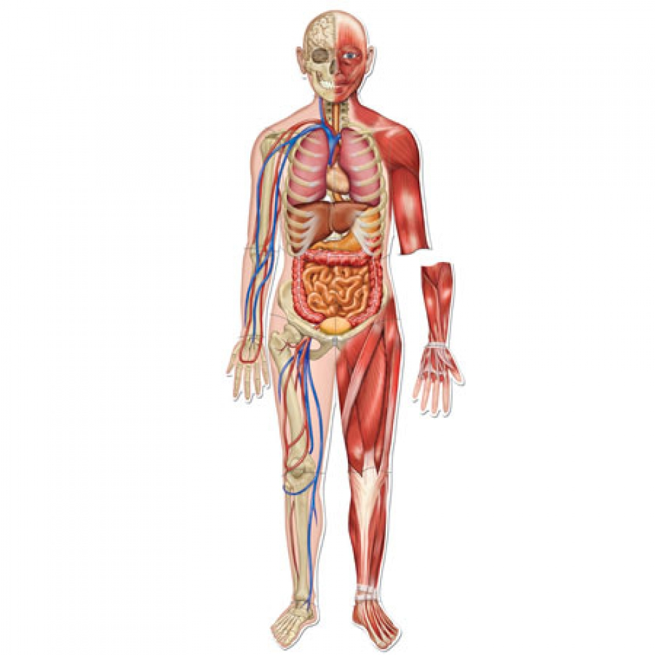
Diagram for assistance:
1
2
3
4
5
6
7
8
9

26. Please now provide further details of any medical condition(s) and treatment received for any item you have ticked (√) in the table above. Ensure you provide dates of diagnosis and treatment, including any treatment plan. Supply as much detail and include any condition not covered in the table, which you feel may impact on your ability to meet the required standard, or would impede your ability to carry out the duties of a private hire driver (please use the continuation sheet at the end of the application form if necessary):

27. DECLARATION:

I DECLARE THAT TO THE BEST OF MY KNOWLEDGE AND BELIEF THE ANSWERS GIVEN IN THIS APPLICATION FORM ARE TRUE. I UNDERSTAND THAT IF I KNOWINGLY OR RECKLESSLY MAKE A FALSE STATEMENT OR OMIT ANY MATERIAL PARTICULAR FROM ANY PART OF THE APPLICATION, WHICH INCLUDES A MEDICAL DECLARATION AND CONVICTION DECLARATION, OR ANY OTHER DOCUMENT SUBMITTED IN SUPPORT OF THIS APPLICATION, I SHALL BE GUILTY OF AN OFFENCE WHICH IS PUNISHABLE BY A FINE OF UP TO £1000.00.

Signature: ……………………………………………………………………………… Date: ……………………………………………………

Print Name: ……………………………………………………………………………………………………………………………………………

28. Statement of Fitness
If a medical condition(s) has been identified at number 25 above ‘Medical Declaration’ or following the completion of a Certificate of Medical Fitness, then your doctor must complete the Statement of Fitness form below.
The Statement of Fitness form can only be completed by the Doctor that you have been registered with for the last twelve months and the Doctor must confirm that they have access to your medical records and that you meet the DVLA Group 2 Medical Standards.
For additional information please see Section 5. ‘Medical Fitness’ in the attached GUIDANCE NOTES and also the DVLA ‘Assessing fitness to drive – a guide for medical professionals’, a copy is available to view at www.gov.uk/government/publications/at-a-glance.
Doctors full name:
Patients full name:
Patients date of birth:
Patients address:
Medical condition(s):

Treatment(s):
Additional information (please continue on additional sheet if necessary and please number all additional sheets and insert number of sheets here):
In assessing the medical fitness to hold a licence to drive a private hire/hackney carriage vehicle, I have applied the current best practise advice contained in the booklet “Fitness to Drive”: A Guide for Health Professionals published on behalf of the Department of Transport by The Royal Society of Medicine Press Limited ((RSM) in 2006. I understand that this recommends that the Group 2 medical standards applied by DVLA in relation to bus and lorry drivers should also be applied by Local Authorities to taxi drivers. I confirm that for the patient detailed above I have access to their medical records and can confirm that the patient is medically fit to undertake the duties of a hackney carriage/private hire driver and to drive a hackney carriage/private hire vehicle and meets the requirement of the DVLA Group 2 Medical Standards and I am aware that this licence can be issued for a period of up to three years.

Doctors signature: Date:
Practice address or practice stamp:


DVLA - Data Protection Mandate
Bolton Council
Licensing Unit
Bolton Town Hall
Victoria Square
Bolton
BL1 1RU
Telephone: 01204 336584
Email: licensing.unit@bolton.gov.uk

Mandate for Release of Information in Accordance with the Provisions of the General Data Protection Regulation

Complete all sections below and SIGN and DATE:

Driver Details

Surname: ___________________________________________________________________________________

First name(s): ________________________________________________________________________________

Date of Birth: _________________________________________________________________________________

Home Address and Postcode: __________________________________________________________________

______________________________________________________________________________________________

______________________________________________________________________________________________

DVLA
Licence No.

Declaration:

Being the person referred to above, I authorise Bolton Council’s Licensing Team to ask the Driver and Vehicle Licensing Agency (DVLA) for my driver record information as and when they require, at a frequency they shall determine.

I authorise and direct DVLA to disclose to Bolton Council’s Licensing Team, all relevant information relating to my driver record from the computerised register of drivers maintained by DVLA. This includes personal details, driving entitlements, endorsement details, disqualifications, convictions and photo images. Medical information is not to be provided.

This authority will expire when I cease to drive in connection with Bolton Council and in any case three years from the date of my signature.

Day Month Year

Drivers Signature: _____________________________________ Date: _____ / _____ / _______

Continuation sheet - please insert the number of the question(s):
(continue on additional sheets if necessary)

