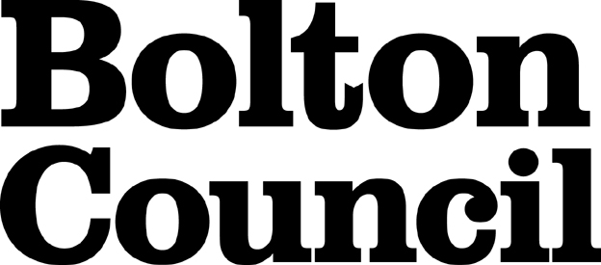

Community Right to Bid Nomination Form

If you need assistance in completing this form please refer to the Guidance Note or alternatively email legal.services@bolton.gov.uk. Further advice can be found at the My Community Rights website.

Section 1 - Information required about the asset to be nominated
Name of asset
Address of asset
Postcode
Name and address of the owner of the asset
Current occupier/s of the asset
Section 2 - About your organisation
Name of organisation
Title |  |  | First name
Surname
Position in the organisation
Email address
Address
Postcode
Telephone |  |  | Mobile
Only certain types of groups / organisations are eligible to nominate assets. Please indicate the nature of your organisation by entering a cross in one of the boxes below.
Organisation type | Parish Council |  |  | Neighbouring Parish Council
Organisation type | Unincorporated group |  |  | Neighbourhood forum
Organisation type | Community Interest Group with a local connection
How many members do you have?
[ this is particularly important for Unincorporated Groups ]
For an organisation to nominate an asset it must be able to demonstrate that its activities are wholly or partly concerned with the Bolton Council area where the asset is located, or with a neighbouring authority.
Section 3 - Supporting information for nomination
Any information entered in this section only may be copied and passed onto the owner of the property you are nominating.

The definition of an Asset of Community Value can be found in the Guidance Notes.
Why do you feel the asset is of community value?
Please give as much information as possible.
Section 4 - Boundary of the asset
What do you consider to be the boundary of the property?
Please give as much detail and if possible include a plan.
Section 5 - Attachment checklist
Copy of group constitution (if you are a constituted group)

Names and addresses of 21 members registered to vote in nomination area
(if group is not incorporated)

Site boundary plan (if possible)

Section 6 - Declaration
I can confirm that to the best of my knowledge the information contained in this nomination form is complete and accurate. I understand that the above information will be used in the process to assess this nomination in accordance with Part 5, Chapter 3 of the Localism Act 2011 and associated regulations.
Signed | Date
Bolton Council will process this information in accordance with the Data Protection Act and in line with the council’s Data Protection Policy.

The information provided will be subject to the Freedom of Information Act, but personal information (names and contact details) will not be released in response to requests.

Section 7 - Submitting your completed nomination form
Please send your completed nomination form to legal.services@bolton.gov.uk.

