Top Tips for completing the ePEP
Please follow these instructions to ensure you can submit each section of the ePEP successfully.
Part 3 – Designated Teacher
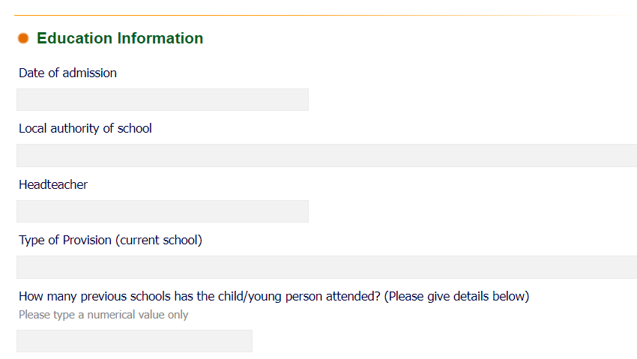

This must be a number!

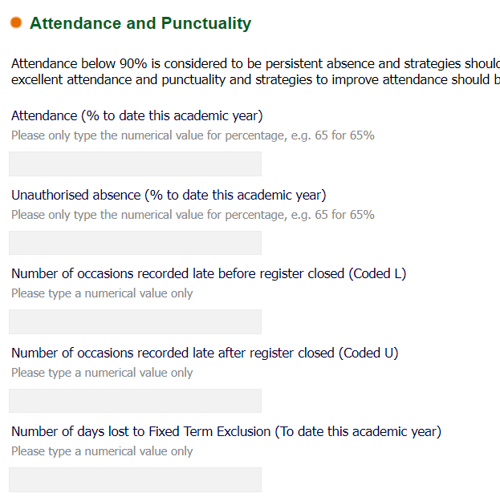

Numbers only! Please do not use decimals or % symbols.

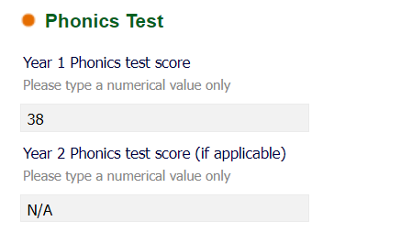

Numbers only! If you do not have a score, leave it blank.

Part 4 - PEP Meeting
Confirm both the date and the time.

