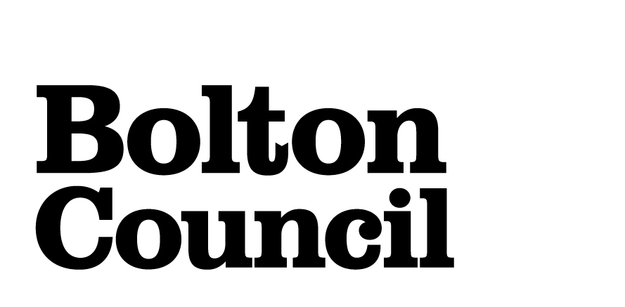
REQUEST FOR FREE SCHOOL BUS PASS
2023/24 SCHOOL YEAR
To qualify for a free school bus pass, you must fulfil one of the criteria below. If you feel you do meet the criteria, then please complete the application in full, and return with appropriate evidence to support your application.
If your application is approved, then you will be sent a letter to complete and sign accepting the terms and conditions. This letter will also include a section for your faith leader to sign (where relevant) to confirm attendance and must be returned together with a passport size photograph.
If your application is refused, you will have the right to appeal against this decision. The reasons for refusal and how to appeal will be sent to you in a letter.
Full details of the Home to School Transport Policy can be found at https://www.bolton.gov.uk/school-travel/assistance-transport-costs-school-college

QUALIFYING CRITERIA
- Attend the nearest qualifying school to the child’s main home address and travel more than 2 miles, if under the age of 8, or 3 miles if aged 8 and over.

OR

- The family must be entitled to free school meals for the child or be in receipt of their maximum working tax credit (i.e., Not reduced by income – this usually appears on Page 4 of your benefit letter under Part 2 “How we work out your tax credits” – “Working Tax Credit Elements” – “reduction due to income”)

AND ALSO

- Attend their nearest qualifying primary school and be over 2 miles from that school, or
- attend one of their three nearest qualifying secondary schools and travel between 2 and 6 miles to that school, or
- attend their nearest available secondary denominational school (if there is evidence to support the child’s admission to that school on denominational grounds) and travel between 2 and 15 miles to that school.

All journeys are measured by the shortest walking route along which a child could walk in reasonable safety accompanied as necessary by an adult. Transport routes only apply to journeys of between 6 and 15 miles.

The return address for this form once complete is:
Email to ITU.applications@bolton.gov.uk
Or by post to:
Bolton Council
Integrated Transport Unit
Mayor Street Depot
Ellesmere Street
Bolton
BL3 5DT

2023 24 SCHOOL YEAR
 | Child’s Surname | Child’s Forename | Date of birth | Year Group | School
1
2
3
4

Has the child(ren) had a free bus pass before? | YES / NO | IF YES, WHEN?

Current address
Postcode
How long has the child/ children lived at this address? | Years | Months
Is this the child/children’s main home address?  Is this a temporary address?  If yes, please provide further details | Yes | No
 | Yes | No
Previous address
Postcode
How long did the child/ children live at the previous address? | Years | Months

Parent/ carer name | Mr / Mrs / Miss / Ms / other
Relationship to children
Telephone number
Email address

LOW INCOME CATEGORY

Are you entitled to free school meals for your child(ren)? | Yes | No
If Yes evidence must be provided i.e., Copy of your letter of entitlement to free school meals.

Are you in receipt of your maximum working tax credit? | Yes | No
If yes evidence must be provided i.e., a full copy of your letter of entitlement to Working Tax Credit
If yes to either of the above, are you attending the school on denominational grounds? | Yes | No
If yes, which religion are you and the child a worshipping member of?
.
Any other relevant information which supports how you meet the criteria:

Signed
Date

