Bolton Safeguarding Adults Board

Working in partnership to prevent adult abuse and neglect
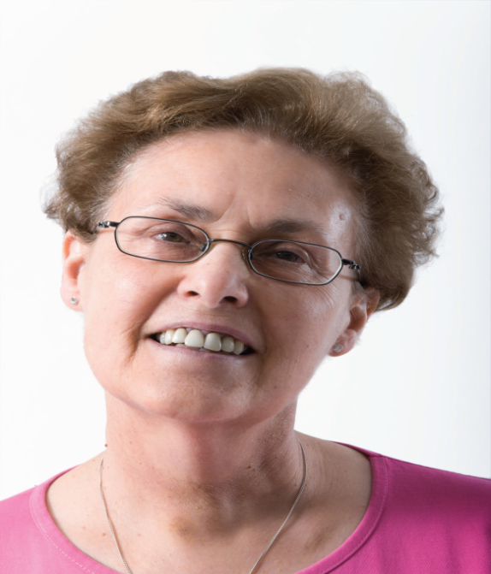
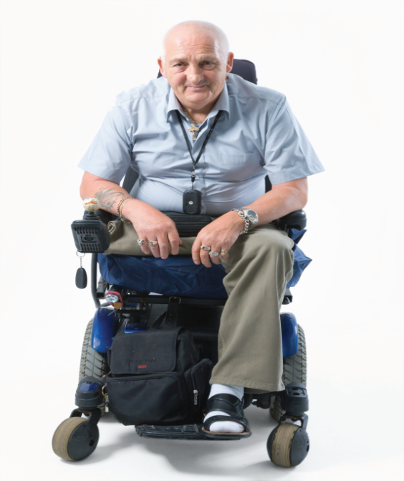
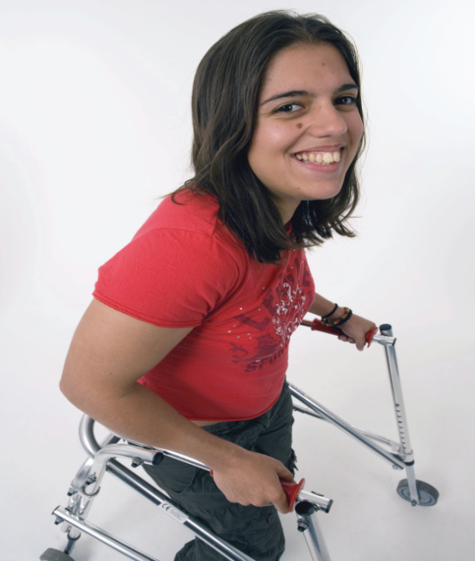

Safeguarding Adult Review Policy (SAR)

July 2018

Contents
Bolton Safeguarding Adults Board 1
Working in partnership to prevent adult abuse and neglect 1
Safeguarding Adult Review Policy (SAR) 1
July 2018 1
1. Introduction 4
2. Statutory requirements of the Care Act 2014 4
3. Purpose of a Safeguarding Adults Review 4
4. Criteria for conducting a Safeguarding Adults Review 5
5. Requesting Information from Agencies 6
6. The purpose of a Safeguarding Adults Review 7
7. The Safeguarding Adults Review Coordinating 7
8. Referral of cases for a Safeguarding Adults Review 7
9. Consideration of referred cases 8
10. Commissioning an Author 9
11. SAR Timescales 9
12. Conducting a Safeguarding Adults Review 9
13. Family involvement 10
14. Production and publication of Safeguarding Adults Review reports 10
15. Acting on recommendations 11
16. Links to other statutory review processes and Parallel legal Processes 11
Appendix 1 Section 44 of the Care Act 2014: Safeguarding Adults Reviews 12
Appendix 2a Safeguarding Adults Review referral process 13
Appendix 2b GMP Process for DHR, SCR and SAR 14
Appendix 2c CCG Process to access Primary Care Information 15
Appendix 3: GM Safeguarding Adult Review Notification Form 16
Appendix 4 Chairs Check list for SAR Panel 22
Appendix 5 Safeguarding Adults Reviews 24
Glossary 26

1. Introduction
1.1 The Care Act 2014 is a long-awaited landmark for Adult Social Care, bringing together the best of social care legislation and national policy that has developed over decades of local government practice. This legislation supersedes any existing social care legislation and as such replaces the document ‘No Secrets’ issued by DoH under section 7 of the Local Authority Social Services Act 1970, which gave guidance on developing and implementing multi-agency policies and procedures to protect adults from abuse.

2. Statutory requirements of the Care Act 2014
2.1 The Care Act 2014 requires each local Safeguarding Adults Board (SAB) to arrange a Safeguarding Adults Review (SAR) to be held in circumstances set out in Section 44 of the Act (Appendix 1 of this document).
2.2 The following procedure has been produced by Bolton Safeguarding Adults Board (BSAB) to ensure compliance with the Care Act 2014. It is informed by the accompanying statutory guidance to the Care Act, in particular paragraphs 14.133 to 14.149.

3. Purpose of a Safeguarding Adults Review
3.1 The purpose of a Safeguarding Adults Review is to:
- Establish whether there are lessons to be learnt from the circumstances of the case, about the way in which local professionals and agencies work together to safeguard adults at risk.
- Identify how lessons learned will be acted upon and what is expected to change as a result.
- Disseminate lessons learned, promoting effective practice and improvement action to minimise the risk of future deaths or serious harm occurring.

3.2 Safeguarding Adults Reviews are not to apportion blame, or to further investigate the death or injury. The following principles should be applied by SABs and their partner agencies to all reviews:
- There should be a culture of continuous learning across all organisations that work together to safeguard and promote the wellbeing and empowerment of adults.
- The approach taken to reviews should be proportionate, according to the scale and level of complexity of the issues being examined.
- Reviews of serious cases should be held by individuals who are independent of the case under review and of the organisations whose actions are being reviewed. Professionals should be involved fully in reviews and invited to contribute their perspectives without fear of being blamed for actions they took in good faith. The reviews should encourage honesty, transparency and sharing information to obtain maximum benefit for them.
- Families should be invited to contribute to reviews. Early discussions need to take place with the adult, family and friends to agree how they wish to be involved ensuring openness and engagement in the process from an early stage. Consideration should be given to offering the adult or the families an advocate to support them/ advocate of their behalf during this process

4. Criteria for conducting a Safeguarding Adults Review
4.1 Criteria taken from the Care Act 2014.
(1) An SAB must arrange for there to be a review of a case involving an adult in its area with needs for care and support (whether or not the local authority has been meeting any of those needs) if—
(a) there is reasonable cause for concern about how the SAB, members of it or other persons with relevant functions worked together to safeguard the adult, and
b) condition 1 or 2 is met.
(2) Condition 1 is met if—
(a)the adult has died, and
(b)the SAB knows or suspects that the death resulted from abuse or neglect (whether or not it knew about or suspected the abuse or neglect before the adult died).
(3) Condition 2 is met if—
(a)the adult is still alive, and
(b)the SAB knows or suspects that the adult has experienced serious abuse or neglect.
(4) An SAB may arrange for there to be a review of any other case involving an adult in its area with needs for care and support (whether or not the local authority has been meeting any of those needs).
(5) Each member of the SAB must co-operate in and contribute to the carrying out of a review under this section with a view to—
(a)identifying the lessons to be learnt from the adult’s case, and
(b)applying those lessons to future cases.

5. Requesting Information from Agencies
5.1 Criteria taken from the Care Act 2014.

(1)If an SAB requests a person to supply information to it, or to some other person specified in the request, the person to whom the request is made must comply with the request if—
(a)conditions 1 and 2 are met, and
(b)condition 3 or 4 is met.

(2)Condition 1 is that the request is made for the purpose of enabling or assisting the SAB to exercise its functions.

(3)Condition 2 is that the request is made to a person whose functions or activities the SAB considers to be such that the person is likely to have information relevant to the exercise of a function by the SAB.

(4)Condition 3 is that the information relates to—
(a)the person to whom the request is made,
(b)a function or activity of that person, or
(c)a person in respect of whom that person exercises a function or engages in an activity.

(5)Condition 4 is that the information—
(a)is information requested by the SAB from a person to whom information was supplied in compliance with another request under this section, and
(b)is the same as, or is derived from, information so supplied.

(6)Information may be used by the SAB, or other person to whom it is supplied under subsection (1), only for the purpose of enabling or assisting the SAB to exercise its functions.

6. The purpose of a Safeguarding Adults Review
6.1 A SAR seeks to determine what the relevant agencies and individuals involved in the case might have done differently that could have prevented harm or death. This is so that lessons can be learned from the case and those lessons applied to future cases to prevent similar harm occurring again.
6.2 The purpose of a SAR is not to hold any individual or organisation to account. Other processes exist for that, including criminal proceedings, disciplinary procedures, employment law and systems of service and professional regulation, such as Care Quality Commission (CQC), Nursing and Midwifery Council (NMC), Health and Care Professions Council and General Medical Council (GMC).
6.3 It is vital, if individuals and organisations are to be able to learn lessons from the past, that SARs are seen to be trusted and safe experiences that encourage honesty, transparency and sharing of information, in order to obtain maximum benefit from them. If individuals and their organisations are fearful of SARs their response will be defensive and their participation guarded and partial.
6.4 BSAB is, therefore, committed to ensuring that SARs are undertaken for the clear purposes of driving positive change and improvement in practice, rather than as a punitive or accusatory process.

7. The Safeguarding Adults Review Coordinating
7.1 The responsibility for coordinating and responding to requests for SAR reviews in Bolton lies with the Board Manager.
7.2 The Board Manager supports the delivery of SAR responsibilities.
7.3 The SAR panel will consider requests for SARs on a case by case basis and will meet as required to discuss or address any other relevant SAR related matters.

8. Referral of cases for a Safeguarding Adults Review
8.1 Any individual (including members of the public) may put forward a case for consideration for a SAR.
8.2 A staff member in a partner agency who believes a SAR is warranted should discuss their concerns in relation to the case in question within their organisation before submitting the request.
8.3 The SAR referral form is available on the BSAB website and is found in Appendix 3 of this document.
8.4 A flowchart detailing the SAR referral process is available on the BSAB website and is found in Appendix 3 of this document.

9. Consideration of referred cases
9.1 As per the referral flowchart, the SAR panel will meet to establish whether any case that has been put forward for consideration meets the SAR threshold (see Appendix 1 and Appendix 2 of this document).
9.2 To be quorate, the SAR panel making this decision must always contain at least one representative from the local authority, the police, and a local Clinical Commissioning Group (CCG) as statutory partners. The Board Manager will ensure other relevant partners are also invited to attend or contribute, depending on the nature of the case.
9.3 After consideration, the recommendation from the panel will either be a) the case is dealt with as a SAR, or b) the criteria are not met and the issues are best addressed through other routes. eg internal agency reviews.
9.4 This recommendation will normally be made on the basis of a majority opinion. In the event of disagreement, the Chair of the Board will have the final say. However, any member of the group can take their concerns to the BSAB Chair in the event of fundamental dispute. However, there is a statutory duty under the Care Act 2014 to undertake a SAR where the criteria are met.
9.5 For every case referred for consideration, a written record of the rationale for the decision will be maintained, via SAR meeting minutes and the SAR referral database.
9.6 The GM SAR protocol will be considered and reference in the event of an out of area resident being referred into the SAR process. (this document can be found of the BSAB website – insert link)
9.7 Where it is agreed by the panel that a SAR should be undertaken, the SAR coordinator will seek final approval from the Chair of BSAB before commencing the SAR. This approval should be in writing, and setting out the reasons why that decision has been reached.
9.8 The individual and family, where appropriate, will be contacted to develop a good working relationship in order to achieve the optimum learning outcome and hear the voice of the service user.
9.9 Disagreements on any part of the process will be discussed within the SAR panel in the first instance, if they cannot be resolved concerns can be discussed with the Chair of BSAB, this will include:
-  Whether a SAR is undertaken or not
-  The outcome of the SAR
-  Concerns during the SAR process
9.10 A member of the public may make a complaint to the Local Government Ombudsman if dissatisfied with the response from the Chair of BSAB.

10. Commissioning an Author
10.1 It is expected that those undertaking a SAR will have appropriate skills and experience which should include:

- strong leadership and ability to motivate others;
- expert facilitation skills and ability to handle multiple perspectives and potentially sensitive and complex group dynamics;
- collaborative problem solving experience and knowledge of participative approaches;
- good analytic skills and ability to manage qualitative data
- safeguarding knowledge; and
- inclined to promote an open, reflective learning culture.
10.2 Ensuring compliance the BSAB will commission the person(s) with the most appropriate skills set to lead any SAR dependent upon the circumstances of the case to be reviewed. The commissioning process will require the Business Manager to identify suitable people to conduct /author the SAR and agree their participation and remuneration with the chair of the BSAB. This will then be put in writing to the SAR author.

11. SAR Timescales
11.1 The BSAB should aim for completion of a SAR within a reasonable period of time and in any event within six months of initiating it, unless there are good reasons for a longer period being required; for example, because of potential prejudice to related court proceedings11.2 Every effort should be made while the SAR is in progress to capture points from the case about improvements needed; and to take corrective action.

12. Conducting a Safeguarding Adults Review
12.1 The process for conducting a SAR will be determined according to the individual and specific circumstances of the case. No one model will be applicable for all cases.
12.2 The SAR Panel will make the final decision on what is the most appropriate methodology, after consultation and discussion with partner agencies via the panel meeting.
12.3 The approach taken to reviews should be proportionate according to the scale and level of complexity of the issues being examined.
12.4 Each review will normally be led by individuals who are independent of the case under review and of the organisations whose actions are being reviewed.
12.5 The focus and methodology of each review should be on what needs to happen to achieve understanding, to improve practice, and to provide answers for families and friends of adults who have died or have been seriously abused or neglected.
12.6 The SAR panel will agree terms of reference for any SAR they arrange and these will be published and openly available on the BSAB website on http://boltonsafeguardingadultsboard.org.uk
12.7 All information relating to the SAR will be shared confidentially and in line with the board’s Information Sharing Protocol.
12.8 There is a statutory duty for agencies as requested to cooperate in the SAR process. Where differences are experienced and cannot be resolved in a timely manner, the BSAB Manager will formally escalate the issue to the Chair of BSAB for response/resolution.
12.9 Unless there are exceptional circumstances, the expectation is that all SARs are completed within six months of their initiation.

13. Family involvement
13.1 Early discussions will take place with family and friends (and the adult where this is possible) to agree how they wish to be involved.
13.2 The level of involvement of families will be flexible and will be dependent on the nature and circumstances of the case. However, the basic principle is that families should be actively seen as partners in the learning process wherever possible.
13.3 A named individual will be identified to act as the point of liaison with the family.
13.4 A leaflet explaining the SAR process to families is available on the BSAB website and is found as Appendix 4 of this document.

14. Production and publication of Safeguarding Adults Review reports
14.1 An overview report of findings will be produced for every SAR that is undertaken.
14.2 The final draft version of this report will be approved by the Chair of the BSAB based on its meeting the following criteria:
- the report provides a sound analysis of what happened and why. The report will include an introduction, terms of reference, details of facts, analysis and specific and timely recommendations;
- it is written in plain English;
- it contains findings of practical value to organisations and to persons who have contact with adults who have care and support needs; and
- it is as concise and focused as possible.

Once ratified, the SAR will be published on the BSAB website.

15. Acting on recommendations
15.1 The author will be invited to the Board meeting to present the recommendations of the report, or if the case is complex, a separate extraordinary meeting will be convened. It is the role of the Board to sign off those recommendations.
15.2 The recommendations and action plans from each SAR will be monitored by the board.
15.3 How this is managed will be decided by the board on a case by case basis.
BSAB will include the findings from any SAR in its annual report and what actions it has taken, or intends to take in relation to those recommendations and findings.
15.4 If, for whatever reason, BSAB decides not to implement an action then it will state the reason for that decision in the annual report.

16. Links to other statutory review processes and Parallel legal Processes
16.1 There are separate requirements in statutory guidance for both a child Serious Case Reviews (SCR) and a Domestic Homicide Reviews (DHR).
16.2 These reviews may sometimes be relevant to a SAR (e.g. because they concern the same perpetrator or because they meet the criteria for more than one review). Where this is the case, consideration will be given to how SARs, DHRs and SCRs can be managed in parallel in the most effective manner possible.
16.3 In setting up a SAR the board, through the SAR coordinator, will therefore consider how the process can dovetail with any other relevant investigations that are running in parallel.
16.4 Any SAR will also need to take account of a coroner‘s inquiry and or any criminal investigation related to the case, including disclosure issues, to ensure that relevant information can be shared without incurring significant delay in the review process. The Board also has legal requirements to share information relating to the SAR with the coroner.
16.5 It will be the responsibility of the Board Manager to ensure contact is made with the Chair of any parallel process in order to minimise avoidable duplication.

Appendix 1 Section 44 of the Care Act 2014: Safeguarding Adults Reviews

- An SAB must arrange for there to be a review of a case involving an adult in its area with needs for care and support (whether or not the local authority has been meeting any of those needs) if—

(a) there is reasonable cause for concern about how the SAB, members of it or other persons with relevant functions worked together to safeguard the adult, and
(b) condition 1 or 2 is met.

(2) Condition 1 is met if—
(a) the adult has died, and
(b) the SAB knows or suspects that the death resulted from abuse or neglect (whether or not it knew about or suspected the abuse or neglect before the adult died).

(3) Condition 2 is met if—
(a) the adult is still alive, and
(b) the SAB knows or suspects that the adult has experienced serious abuse or neglect.

(4) An SAB may arrange for there to be a review of any other case involving an adult in its area with needs for care and support (whether or not the local authority has been meeting any of those needs).

(5) Each member of the SAB must co-operate in and contribute to the carrying out of a review under this section with a view to—
(a) identifying the lessons to be learnt from the adult’s case, and
(b) applying those lessons to future cases.

Appendix 2a Safeguarding Adults Review referral process
Email of the referral form sent to LA, CCG and Police for initial screening.
Is there agreement that the referral should proceed to the next stage?

Recommendation to not proceed to scoping exercise to be documented with a written response to be sent from the Chair of the Board to the referring agency or family.
Email sent to all agencies for involvement with the case. Chronologies to be collated by BSAB manager. Once all received a panel will interrogate the information and make a recommendation to the board as to whether the case requires a SAR
Further information requested and obtained from referrer
Yes
No
Yes
BSAB Chair and Manager will instigate extraordinary SAR, request meeting or interim action
No
Yes
Are there urgent matters which need to be addressed?
No
Is SAR request completed and clear?
Request acknowledged and forward to the BSAB Manager
SAR request received via a secure email

Appendix 2b GMP Process for DHR, SCR and SAR
Recommendations progress meeting with Manager of Investigation & Safe-guarding Review Team.
SeriousCase.ReviewTeam@gmp.police.uk
SCR Unit to complete scoping document. Submit to LSCB / SAB/CSP for consideration of a review.
IMR sent to relevant board. Agreed single agency recommendations collated by SCR unit and allocated to relevant area lead. Shared with the OLB on Form 1194
Action plan completed and signed off by .Manager of Investigation & Safe-guarding Review Team and Relevant Cluster Lead. Returned to relevant board for sign off.

If DHR—Major Crime review team produce IMR. Panel member is responsible for relaying terms of reference and key dates to IMR author.

SCR Unit to attend consideration / scoping meeting. If approved by relevant board, GMP SCR Unit to allocate panel member.
IMR QA IMR and single agency recommendations agreed by Manager of Investigation & Safeguarding Review Team
Once draft report published SCR Unit to collate any multi agency recommendations. SCR unit to send to relevant Cluster lead.

Review commissioning meeting takes place with panel member. Terms of Reference Established.
Investigation & Safeguarding Review Team produces draft IMR with recommendations / action plan where appropriate.
Panel member responsible for attending all meetings and producing IMR (dependent on LSCB methodology) and identify GMP Early Learning
Review closed pending publication

Appendix 2c CCG Process to access Primary Care Information
BSAB Manager to request for primary care information from bolccg.quality-team@nhs.net when scoping out a SAR.

Information to be sent to BSAB Manager e.g GP name, address of surgery and secure email address.

CCG Designated Safeguarding Professionals will support Primary Care with chronologies
BSAB Manager will liaises with primary care/ CCG if further information is required
BSAB Manager will write to GP/Primary Care and ask for their support around the case

All requested information to be sent back to the designated email address FAO BSAB Manager

Appendix 3: GM Safeguarding Adult Review Notification Form
CONFIDENTIAL WHEN COMPLETED

SAFEGUARDING ADULT REVIEW REFERRAL FORM

Cases should be referred initially to the SAB lead for your organisation for consideration if an adult at risk of abuse or neglect has died or been seriously harmed, and abuse and neglect are believed to have been a factor.

This form can be completed by any professional who has become aware of a case where the above criterion is met. All information provided should adhere to information sharing protocols and have due regard to the Mental Capacity Act and Best Interest Decision protocols.

Please note there is a statutory (Care Act 2014 Section 45) for agencies to share relevant personal data with the Safeguarding Adults Board.

To make a referral please complete this form only
- Provide as much information as is known at the time you complete referral in order to make a notification to the SAB
- If information is not available at this time do not delay in sending in notification

REFERRAL DETAILS
Date of Notification
Name of Referrer
Role of Referrer
Agency
Address
Tele
Email
Name of agency safeguarding lead
ADULT DETAIL (SUBJECT OF REFERRAL)
First Name(s) |  | Surname
Known Alias(is)
Date of Birth
Home Address
Date of Death  (if applicable) |  | Date of Incident  (if applicable)
Gender |  | Disability
Ethnicity |  | Faith / Religion
GP Name |  | GP Practice Contact Details

LEGAL STATUS OF ADULT (tick as appropriate)
Detained under Mental Health Act |  | Subject to Section 117 (Mental Health Act)
Lasting / Enduring Power of Attorney Registered for Health/and, or Finances? |  | Subject to Deprivation of Liberty Safeguards (DoLs) & Liberty Protection Safeguards (LPS)
Legal Status Unknown |  | Other (please add in)

HAS THE PERSON OR THEIR REPRESENTATIVE BEEN CONSULTED ABOUT THE REFERRAL? YES/NO
(Further Comments)

CRITERIA FOR SAFEGUARDING ADULT REVIEW
(1) An SAB must arrange for there to be a review of a case involving an adult in its area with needs for care and support (whether or not the local authority has been meeting any of those needs) if -

- there is reasonable cause for concern about how the SAB, members of it or other persons with relevant functions worked together to safeguard the adult, and

- condition 1 or 2 is met.

(2) Condition 1 is met if –

- the adult has died, and

- the SAB knows or suspects that the death resulted from abuse or neglect (whether or not it knew about or suspected the abuse or neglect before the adult died).

(3) Condition 2 is met if -
(a) the adult is still alive, and

(b) the SAB knows or suspects that the adult has experienced serious abuse or neglect.

(4) An SAB may arrange for there to be a review of any other case involving an adult in its area with needs for care and support (whether or not the local authority has been meeting any of those needs).

(5) Each member of the SAB must co-operate in and contribute to the carrying out of a review under this section with a view to -
(a) identifying the lessons to be learnt from the adult’s case, and

(b) applying those lessons to future cases.

PLEASE GIVE AS MUCH INFORMATION AS POSSIBLE TO DEMONSTRATE REASON FOR REFERRAL AND THAT CRITERIA IS MET.

PLEASE NOTE THAT PURPOSE OF REFERRAL IS TO DETERMINE IF CASE MEETS CRITERIA FOR A SAR OR ANOTHER TYPE OF REVIEW OR AUDIT AT THIS STAGE

RATIONALE FOR REFERRAL
(please detail the reason for referral when considering the above criteria)
Date(s) of Incident |  | Date of Death
Location of Incident
Outline events and circumstances which triggered referral: This is to help establish if the case meets the criteria for conducting a Safeguarding Adult Review – you do not have to provide detailed analysis at this stage

REASON FOR ANY DELAY IN REFERRAL

ACTIONS ALREADY TAKEN (provide summary of outcome of Section 42 and case conference if appropriate)

IS A CORONER KNOWN IN THIS CASE (Details of information to be provided below)

AGENCIES KNOWN TO BE INVOLVED WITH THE ADULT (please include names and contact details)

Name | Agency | Contact details | Are they still involved?

Any comments and Sign off by your agency Safeguarding Lead
This is to confirm that the referral has been quality assured regarding information provided

Name _________________________________ Date
Referrer Name _______________________________ Date
Sign off by Safeguarding Lead
Name _______________________________ Date

THIS REFERRAL IF NOW COMPLETE.

PLEASE EMAIL THE COMPLETED FORM TO (charlotte.thaker@bolton.gov.uk)

For Completion by SAB Business Unit
Initials of Adult
Date referral received by SAB
Date referral received by Chair of SAB SAR Sub Group
Date of call for information to agencies
Deadline for agencies to submit information
Date of initial screening meeting
Date recommendations submitted to SAB Chair
Date of decision of SAB Chair

Appendix 4 Chairs Check list for SAR Panel
The adult in the area has care and support needs (whether or not the local authority has been meeting any of those needs)
Condition |  | Criteria | Yes | No | Unsure
 | a | There is reasonable cause for concern about how the SAB, or members of it or other persons with relevant functions worked together to safeguard the adult
 | b | Condition 1 or 2 must be met
1 | a | The adult has died
 | b | The SAB knows or suspects that the death is a result from abuse or neglect (whether or not knew about or suspected the abuse or neglect before the adult died)
2 | a | The adult is still alive
 | b | The SAB knows or suspects that the adult has experienced serious abuse or neglect
 |  | Does this case meet the criteria for a full SAR?

Are there any other statutory reviews currently taking place?
DHR |  | Serious Incidents (NHS) |  | SCR |  | Police Investigation |  | Coroner |  | Other
yes | no | yes | no | yes | no | yes | no | yes | no | yes | no

Preferred Methodology | Yes | No | Rational
Welsh Model
Systems Approach
Combined Chronology, IMR and Review panel
Single Agency Review

Recommendation to the Chair of Bolton Safeguarding Adults Board

Key themes for the SAR to consider?

Appendix 5 Safeguarding Adults Reviews

Introduction
When an adult who needs care and support either dies or suffers serious harm, and when abuse or neglect is thought to have been a factor, Bolton Safeguarding Adults Board (BSAB) may need to review what has happened. This is called a Safeguarding Adults Review or SAR for short.

These reviews are to see whether any lessons can be learned about the way organisations worked together to support and protect the person who suffered harm.
The people in charge of the review understand this is likely to be a very difficult time for families, friends and carers, but they want to learn as much as possible about how to do things better in the future.

The BSAB wants families and carers to be involved in the process as much as possible. They believe families, carers and the person who suffered harm should have the opportunity to discuss any concerns they may have and to share their thoughts and opinions.
This leaflet tells you what happens when a SAR is required to be undertaken, and what you should expect.

What is a Safeguarding Adults Review?
A Safeguarding Adults Review (SAR) is held to find out how organisations, families, friends, carers and care professionals can work together better to keep adults who need care and support safe from abuse or neglect.

A SAR is not an enquiry into the cause of an individual death or injury. It does not look for someone to blame and it is completely separate from any investigation being undertaken by the police or a coroner. The SAR concentrates on whether care professionals can learn anything from what happened.

How do we carry out a SAR?
There are different ways in which a SAR can be done, but they all involve gathering as much information from as many sources as possible. The review team can then try to work out exactly what happened, and why. They will consider whether things could or should have been done differently, and ask how things could be done better in the future. The findings are then summarised in a public written report, normally published by the BSAB. It is, therefore, a public document. However, no individuals are named in it and no information is included that could lead to the people involved being identified.

A SAR will often find there have been lots of agencies involved in the person’s life. Sometimes the best way forward is to ask the people who were directly involved in the case to sit round a table together, and discuss face-to-face what happened. An independent chairperson, who had no involvement in the case, will help the discussion. A panel of other professionals will then consider whether we have found out what we needed to know, before the final report is written.

The BSAB will choose the best approach. You will see a final report written by someone independent of the case, identifying what has been learnt, and what recommendations for change have been made.

Family, friends and carer involvement
A really important part of undertaking a SAR is to ask you, the family, for your opinion about what happened. Your views should be reflected in the final report. We will discuss with you how best to do this and make sure you are kept up-to-date.
Sometimes a SAR can take several months to complete, but we will update you regularly and explain the reasons for any delays.

Glossary
BSAB | Bolton Safeguarding Adults Board
SAR | Safeguarding Adults Review
CCG | Clinical Commissioning Group
LA | Local Authority
SAB | Safeguarding Adult Board
CQC | Care Quality Commission
NMC | Nursing and Midwifery Council
GMC | General Medical Council

