**Bolton  
Youth**  **Offending Team  
Management Board Induction   
2020 / 21**

**Bolton Youth Offending Team – Local Context**

Bolton is a Metropolitan Borough Council, serving the town of Bolton and a number of smaller towns and villages. The borough is a diverse area, combining both urban and rural districts. The borough contains some of Greater Manchester’s most affluent communities, and some of its most challenged.

The borough borders on 5 other local authority areas within and outside Greater Manchester. The borough works closely with the Greater Manchester Combined Authority and the YOT maintains close relationships with neighbouring YOTs.

Bolton’s YOT is located within the authority’s Children’s Social Care division. This decision was taken to support improved joint working between the Youth Offending Team and other services which support children, young people and families. In addition to statutory Youth Offending services, the YOT provides a targeted youth support service, that works with young people aged 8 - 17 years old and their families who are at risk of becoming involved in anti-social behaviour and/or offending.

**Key Facts about Bolton**

* Latest population estimates are that there are 71115 children and young people aged 18 and under in Bolton.
* Bolton is ranked 71st most deprived of 326 local authorities in England on the measure of income deprivation affecting children.
* 20.1% of children are in low income families as identified by HMRC – England Average is 17.0%
* 17.4% of Primary Pupils are eligible for and claiming Free School Meals (FSM) – England Average is 15.7%
* 18.2% of Secondary Pupils are eligible for and claiming FSM – England Average is 14.1%
* 30% of Primary Pupils in Bolton speak English as an Additional Language (EAL) – England Average is 21%
* 23.5% of Secondary Pupils in Bolton EAL – England Average is 16.5%
* 42.5% of Primary Pupils are from an Ethnic Minority – England Average is 34.5%
* 36.8% of Secondary Pupils are from an Ethnic Minority – England Average is 33%
* 33.8% of Special School Pupils are from an Ethnic Minority – England Average is 31%

**Bolton Youth Offending Team Vision 2020/2021**

**Bolton Vision**

The Bolton Vision Partnership brings together senior leaders from the voluntary, community and faith sector, the private sector, the university, college and schools, health, emergency services and the local authority, the partnership has developed this vision for Bolton:

Bolton will be a vibrant place, built on strong cohesive communities, successful businesses, and healthy residents. It will be a welcoming place where people choose to study, work and put down roots.

There are three ‘Guiding Principles’ which underpin the Council’s work with its partners across the borough:

• Inclusive growth and prosperity

• Protecting the most vulnerable

• Reforming our services in partnership

**Bolton YOT Vision**

The YOT Vision supports the Bolton Vision.

To prevent children and young people from offending, engage victims, protect the community, encourage positive life choices and maximise potential for children and young people

The vision is underpinned by 6 strategic priorities which are supported by operational priorities, which are reviewed on an annual basis.

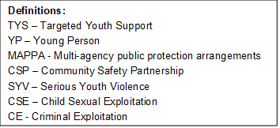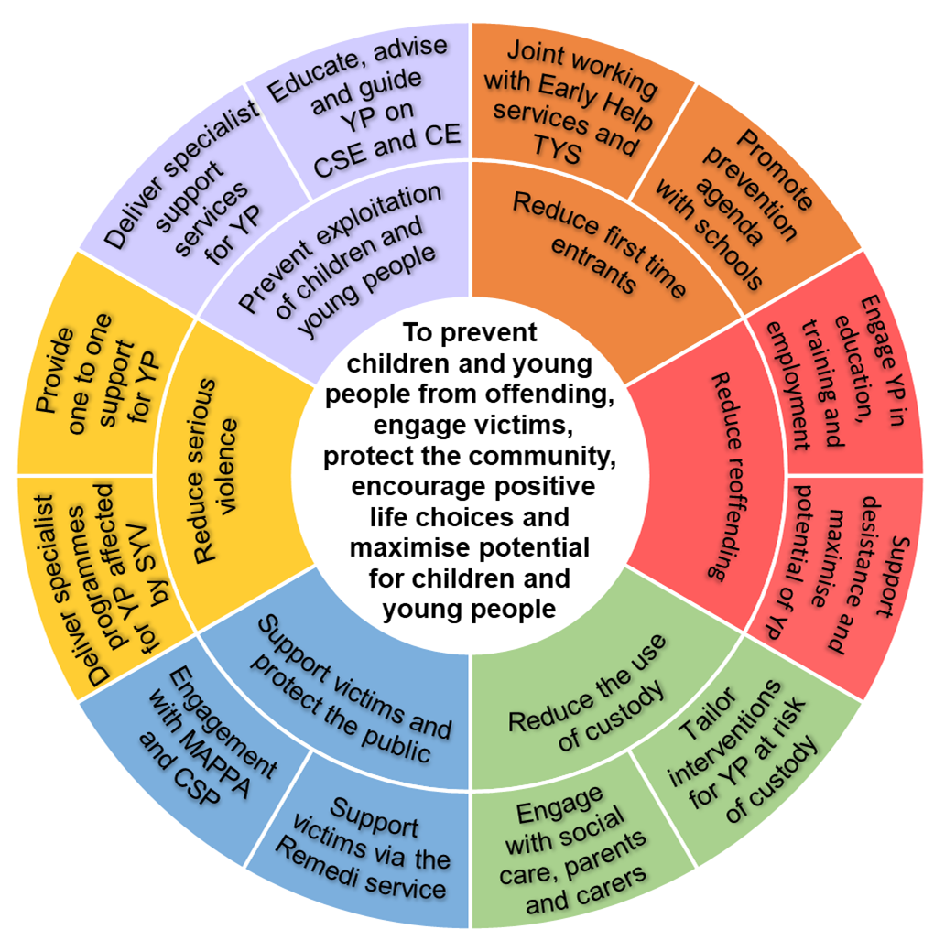

**Youth Offending Team Management Board Function**

A YOT management board should be formed to provide strategic direction, have governance, accountability and oversight of the youth offending service.

The key functions of board members are to:

* Set the strategic direction of the youth service and steer delivery
* Provide and commit sufficient resource including secondments from statutory partners
* Oversee performance of the whole youth justice system locally
* Champion the provision of effective services
* Provide value for money

**An Effective Management Board**

An effective board has the following characteristics:

* all named statutory services are represented at the right senior level, who can commit resources on behalf of their organisations and there is evidence they are doing this.
* other key delivery agencies and stakeholders represented or able to make representation;
* it meets at least quarterly with a continuity of board membership and regular attendance
* individual members are inducted into the role - YOT Managers tasked with this
* are able act as local ‘champions’ for youth justice, advocate effectively and have lead responsibility for key areas of activity
* actively seeks and considers the views of service users, victims of crime and the wider community

**Management board responsibilities**

The terms of reference outline the full roles and responsibilities of the board members.

The key responsibilities of the Board are to:

* Actively oversee the implementation of the Youth Justice Plan (a statutory requirement) and encourages the service to invest in self-assessment and peer review processes as ways of developing practice and improving outcomes;
* Ensures that children and young people with whom the YOT works have access to appropriate mainstream services.
* Have a regular oversight of YOT income and expenditure and its commissioning activity, ensuring the YOT is adequately resourced.
* Have regular oversight of compliance with relevant statutory standards; and
* To ensure there is a culture of learning lessons from community safeguarding and public protection incidents, thematic inspections and other relevant processes
* Ensure that YOT staff receive appropriate training and development opportunities to address any competence deficits

The Board has oversight of performance against the key outcome indicators, no matter how they are delivered locally:

* to reduce re-offending;
* to reduce first time entrants into the youth justice system; and
* to reduce the use of custody

This would ensure an integrated approach to youth crime prevention, offending and re-offending.

**Bolton Youth Offending Management Board**



**Bernie Brown**

**Chair**

Director of Children’s Services

(Bolton Council)

**Policy Strategy & Partnerships Team**

(Bolton Council)

Support Function to the Board

**Rick Jackson**

**Vice Chair**

Divisional Commander Superintendent

(GMP)

**Ian Walker**

Assistant Director of Staying Safe

(Bolton Council)

**Jo Turner**

Head of Service

(Bolton Council)

**Joanne Hickey**

Assistant Chief Officer

(NPS and representing CRC)

**Melissa Maguinness**

Director of Strategic Commissioning

(CCG/Bolton Council)

**Rafael Martinez**

Head of Community Safety

(Bolton Council)

**Lyndsey Nelson**

Virtual Head

(Bolton Council)

**Geraldine Whitehead**

Head of Strategic School Improvement

(Bolton Council)

**Bolton Youth Offending Team Structure**

**Head of Service**

Jo Turner

**1 FTE**

**Operational Manager TYS**

Maureen Nevers

**1 FTE**

**Operational Manager**

Jayne Roscoe

**1 FTE**

**Operational Manager**

Sarah Dawson

**1 FTE**

**Operational Manager**

Lucy Buckingham

**3 FTE YOT Officers**

Jennifer Thomas

Ailsa Woodhead

Roger Gray

**1 FTE ETE Officer**

Gary Scott

**1 FTE Support Workers**

Naveed Akram

**1 FTE Family First Worker**

Mike Holmes

**1 FTE Probation Officer**

Joanne Carlon

**2 FT Support Workers**

Melanie Lockwood

Bill Holmes

**1 FTE Reparation Supervisor**

Michaela Chambers

**3 FTE YOT Officers**

Rachel Mercer

Steve Fletcher

Shona Roscoe

**1 FTE Police Officer**

Jackie Connell

**1 FTE EMHP**

Sharon Noble

**0.2 FTE Health Professional**

Becky Gresty

**0.3 FTE SALT**

Ian Warriner

**1 FTE Support Workers**

Alison Jones

**6 FTE Workers**

Simon Cannon

Kat Fitton

Aaron Dennis

Jim Warner

Ilyas Makka

Vacant

**2 FTE Family First Support Workers**

Claire Jefferson

Aaron McCarthy

**1 FTE Liaison and Diversion**

Kelly Collier

**Induction**

**As part of your induction to the Board you will asked to: -**

1. Meet with the Chair of the Board
2. Attend board meetings and contribute
3. Offer challenge at board meetings
4. Meet each Board member to discuss their role within the Board
5. Shadow the YOT operational staff for one day
6. Familiarize yourself with the YJB plan
7. Understand the vision for Bolton YOT
8. Confirm your commitment to the Board

If the nominated representative cannot attend then another appropriate manager should deputise to ensure continuity of attendance by all partners. Representatives should always be of the appropriate level to be able to make strategic decisions and commit resources as needed.

**Biographies**

**Bernie Brown – Chair of Management Board and Director of Children’s Services (Bolton Council)**

Bernie Brown is the Director of Director of Children’s Services in Bolton.

Bernie has worked in Bolton since November 2017.

Bernie took up the Chair of the YOT Management Board in October 2018.

Bernie is a qualified and registered Social Worker with 30 years’ experience in children’s services.

**Rick Jackson – Vice Chair of Management Board and Divisional Commander Superintendent (GMP)**

My role is that of District Superintendent for Bolton, with responsibility for leading the Policing Response and the Policing response to major events and serious/complex investigations; setting strategic/tactical objectives and priorities, assessing and managing threats/risks and directing the deployment of resources to ensure an appropriate and effective Policing response. In addition to local responsibilities, I have a wider pan-Manchester role in relation to providing leadership to the Policing of critical incidents and major events, such as the Policing response to; Major Incidents and large scale planned events, Public Disorder and CBRN incidents. This necessitates planning and directing activities in line with wider policing priorities to uphold the law and ensure public safety and strengthen public confidence.

As part of my responsibilities for Bolton, I represent Policing and the wider Organisation (GMP) as a member of various strategic groups within the Bolton Partnership; this includes the Bolton YOT Management Board in my capacity as co-chair. My primary responsibility is to contribute to the development of culture, climate and working processes in Bolton, ensuring adherence to standards, and the promotion of accountability and continuous improvement. A key element to this responsibility is in contributing to the formulation of the youth justice plan, and measuring objectives linked to key performance indicators through the YOT Management Board.

**Ian Walker - Assistant Director of Staying Safe (Bolton Council)**

I am Ian Walker and I am the Assistant Director for Staying Safe. I have only been in post since March and so I am very new to the YOT Management Board. I have been a qualified social worker for 26 years during which I would suggest I have experienced most of the roles and functions within social care including some youth offending responsibilities as a practitioner.

The Bolton Staying Safe service incorporates the full range of social care interventions for children and families including Early Help, Referral and Assessment, Safeguarding, LAC and Care Leavers, Fostering, Residential Care, Short Breaks, Child Protection and Exploitation and the Youth Offending Service.

One of the advantages of such a large span of control is that I can corral the disparate parts of the service into providing a co-ordinated and strategic approach to supporting individual client groups. For example, the recently launched Resettlement Policy may require involvement from the LAC/Leaving Care Service, Placements, the Virtual School and the Exploitation Teams and as the Assistant Director  responsible for all of those services I can be more directive in ensuring appropriate levels of support are readily available.

In addition, I am already beginning to develop collaborative relationships with partners at a strategic level including with Health and Bolton at Home and these relationships will be key in the joint development and provision of services within the area of Youth Justice

**Jo Turner - Head of Service (Bolton Council)**

My name is Jo Turner, I have been in my role as the Head of Service for Youth Offending and Targeted Youth Support services in Bolton since October 2019. I have worked within the social care sector for around 14 years predominantly with the Youth Justice and child exploitation services, I recently returned to Bolton, from working in the London Borough of Tower Hamlets where I initially went to write an inquiry into the exploitation of children by organised networks, this led to me supporting the design and development of the Exploitation team whilst undertaking the role as the Head of Youth Justice.

I have previously been a Bolton council employee and was excited to take up the opportunity to return to Bolton as the Head of Service for YOT and TYS, I am responsible for ensuring the services within my profile meet the National standards for children and young people, deliver an outstanding service, safeguard young people, manage risk and protect the public

My responsibility as a Board member is to ensure that the strategic and operational plans are represented, offer the board an overview of the service delivery, data and finance. In addition, the board is appraised of any resource, delivery or safeguarding concerns, we have worked closely as a multi-agency service to ensure that children and young people can live safe, happy and healthy lives free from offending.

**Joanne Hickey - Assistant Chief Officer (NPS and representing CRC)**

My name is Joanne Hickey and I have worked for the National Probation Service for 25 years. Other than a recent 3 year secondment, the majority of my career has been spent in the Wigan and Bolton footprint, and I am delighted to have returned to my home town from 27th July 2020. I have responsibility for the oversight of offender management across Bolton and also co-chair MAPPA level 3 cases with colleagues from GMP.

I have represented the Probation Service on various YOT boards extensively for around seven years in addition to working with GMCA in relation to youth transitions. I also represent the NPS at various strategic forums. I have always enjoyed this area of work particularly the unique contribution that the probation service bring with transitions cases and risk. I am keen to be a challenging and effective board member with a focus on striving for excellence across the partnership.

**Melissa Maguinness – Director of Strategic Commissioning (CCG)**

Melissa has recently joined the Bolton Youth Offending Team (YOT) Board as a CCG Director member. Melissa has worked for Bolton NHS CCG for over 6 years and is a member of the Executive and Board. Her portfolio covers contracting, commissioning and performance for all hospital services, community services, mental health and emotional wellbeing services, funded care and transport. Melissa has responsibility for ensuring that all services provided to the residents of Bolton are high quality, effective and meet their needs – this encompasses people of all ages and preventative services through to specialist inpatient care.

Melissa has a specific interest in improving outcomes for all children and young people; ensuring that they are all able to meet their aspirations and potential and are given the best start in life. The Children and Young People’s commissioning team ensure that all services are designed to meet the needs of our younger residents and provide support at times of need. Melissa and the team are working to ensure that young people who may have experienced adverse life events or challenges which have led them to become involved with Youth Offending Services are given every opportunity to succeed and live healthy, happy lives. Melissa will bring this challenge to the YOT Board to ensure that health commissioned services improve and support the emotional and physical wellbeing of all young people with specific focus on the most vulnerable.

**Rafael Martinez - Head of Community Safety & Neighbourhoods (Bolton Council)**



I have been a Board Member since June 2019 when I took over the post of Head of Community Safety for Bolton Council. This role provides leadership for the council’s community safety function ensuring all statutory requirements are fulfilled (notably through the Community Safety Partnership) and involves the direct management of the following functions; placed-based community safety, anti-social behaviour (including youth related ASB), hate crime, cohesion, preventing radicalisation (Prevent and CHANNEL), domestic abuse. I also have responsibility for the Neighbourhood Management and Area Working functions within the Council.

What I bring to the board is a sound understanding and experience of community safety, how local government can shape both community safety outcomes and work in partnership to ensure these outcomes are long lasting. Community Safety is a broad policy area that covers all aspects of criminality, safety and the perception of safety within society. Reducing reoffending within children is an area of priority for our local Community Safety Partnership (Be Safe) and I am keen to work collaboratively to support this outcome.

I have a good understanding of the strategic enablers and drivers that influence this work area and I am passionate about supporting preventative and early intervention models that stop young people from entering the Criminal Justice System in the first place.

I give commitment and energy to the Board playing an active role in supporting front line practice and seizing opportunities to innovate and test new models and drive change where there is a proven evidence base. I also commit to aligning agendas and shaping policy to maximise improved outcomes for young people.

**Lyndsey Nelson - Virtual Head (Bolton Council)**

**Geraldine Whitehead - Head of Strategic School Improvement (Bolton Council)**

My name is Geraldine Whitehead and I am the Head of Strategic School Improvement in Bolton. I have worked in Bolton for over fifteen years working in schools as a senior leader and for the local authority. I joined the board in September 2019.  I support the board with promoting positive opportunities within education, employment and training for young people liaising with YOT’s Education worker to advise on any opportunities that young people could access within Bolton and provide support from the Connexions Careers Service.

**Policy Strategy & Partnerships Team**

The Policy Strategy & Partnerships Team support and attend the YOT Management Board meetings.

The team provides strategic support to services across the Department of People, and operates in three distinct and interlinking work areas;

* Policy, Performance and Partnerships – business planning support, strategy development, maintenance of policies, equality impact assessments and support the department’s readiness for external inspection.
* Information Analysts – data analysis to support the Department to plan services and deliver improved outcomes for children, young people and adults. This includes mapping and performance indicator profiles.
* Information and Communication – prepare and disseminate information under the council’s statutory information duties for children, families and adults. The team also undertake childcare sufficiency assessments and co-ordinate user experience surveys.

Our support and commitment to the Youth Offending service and the Board involves working closely with the Head of Service, Operational Managers and members of the Board to provide support in the development of plans that support the YOT Vision, assessment of national standards and operational processes to assist in the maintenance of policies, review of inspection guidance to support the service’s readiness for external inspection. We ensure that any information that is produced meets the council’s brand guidance and disseminated appropriately. The team works closely with the service in producing management information reports and contribute to the oversight of performance. The team is committed to supporting both the YOT vision and the overall council vision.