**YOT Vision 2020/2021**

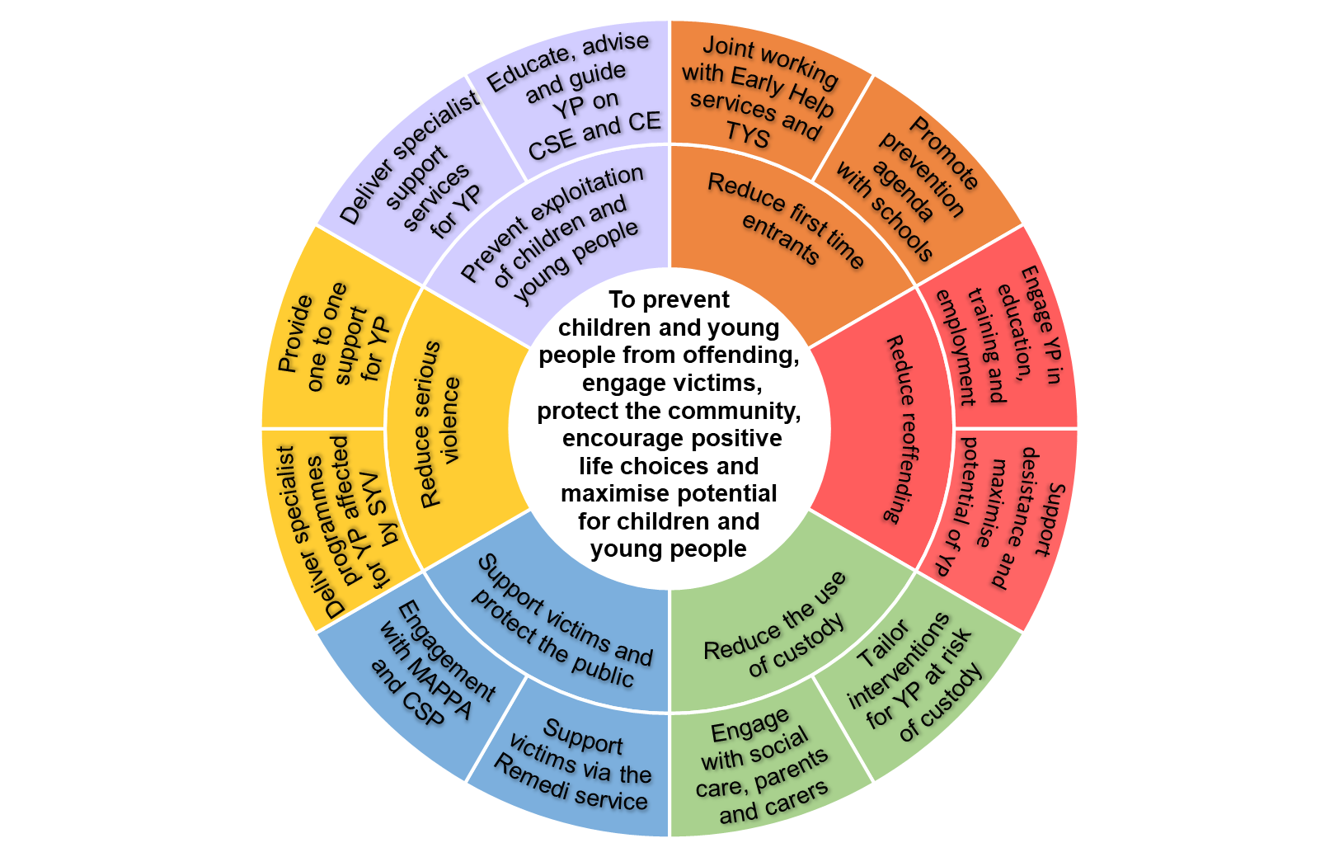

**Definitions:**

TYS – Targeted Youth Support

YP – Young Person

MAPPA - Multi-agency public protection arrangements

CSP – Community Safety Partnership

SYV – Serious Youth Violence

CSE – Child Sexual Exploitation

CE - Criminal Exploitation